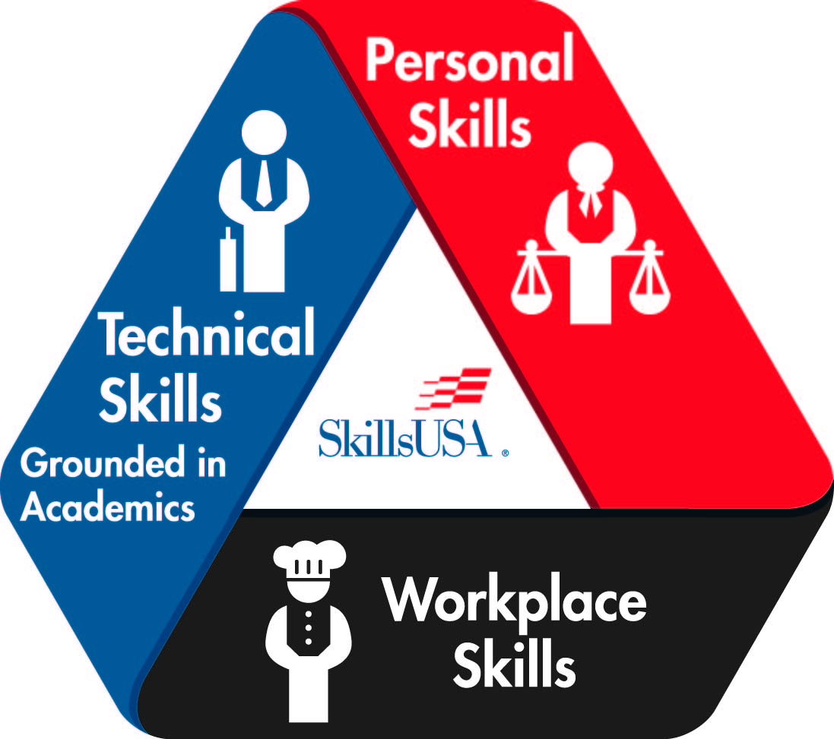
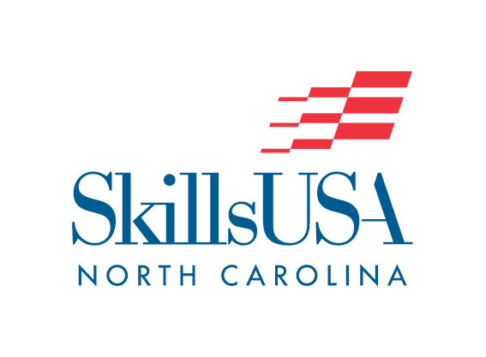
SkillsUSA NORTH CAROLINA
POSTER CONTEST
(REGIONAL/STATE-ONLY CONTEST)

2021 ADJUSTMENTS:
Contestants will submit a PHOTO of their finished Poster.
Poster Photos are to be submitted into the Canvas Contest Portal by April 15 midnight.

This Year’s Theme: SkillsUSA: Champions at Work, Empowered to Succeed

PURPOSE

Evaluate the contestant’s ability to develop and prepare a SkillsUSA promotional poster.

CLOTHING REQUIREMENTS

Official SkillsUSA blazer, sweater, or windbreaker and accompanying official SkillsUSA dress. Refer to General Regulations, Skills Championships Technical Standards.

ELIGIBILITY

1. Open to active SkillsUSA members enrolled in Trade and Industrial Education courses.

EQUIPMENT AND MATERIALS

- Supplied by the Contestant:
- Poster Board.
- Anything used to draw/create the poster.

SCOPE OF THE CONTEST

- The theme for the poster will be the current National SkillsUSA theme/subtheme and must be stated on the poster.

- The poster shall be designed and constructed by one Skills member only.

- Entries shall be constructed on 22” x 28” poster board.

- The entire poster must be HAND-DRAWN. Any part of the poster that is not hand-drawn will incur a penalty.

- Posters may not have any attachments on them (molding, framing, mockups, module, photographs, collages, stick-ons, glitter, etc.).

- Only students will be allowed to set up the posters according to instructions given by the contest chairperson or the conference program.

- Failure to comply with any requirement listed above will result in a penalty for each rule violation.

Scoring

Educational Information Value – 200 pts
Layout and Design – 200 pts
Workmanship – 200 pts
Creativity and Originality – 200 pts
Current Theme Displayed on Poster – 100 pts
Poster Relates to the Current Theme – 100 pts
Resume Penalty – minus 10 pts
Attachment Penalty – minus 200 pts
Includes anything that is not Hand-Drawn – minus -200 pts

