SkillsUSA 2019 Additive Manufacturing State Challenge

Quarter Query - Heads to Tails

Welcome to the “Quarter Query” challenge! The task at hand is to design and use a device made of only 3D printed parts to flip an un-modified U.S. quarter (provided at the competition location) from heads to tales.
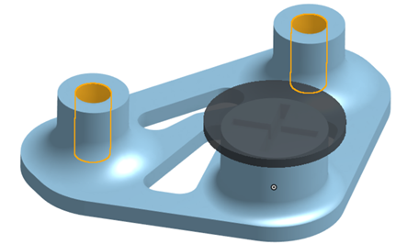

“What’s the catch?” you say. Well, there are four, and here they are:

- The device may only be operated by a single, unbent finger. Note: the device may not attach to the finger in any way.

- The device must remain in contact with at least one Connection Point (orange in the diagram) at all times.

- The quarter will begin heads-up on the Coin Pedestal (X mark) and must finish tails-up back on the pedestal.

- The device must follow these 3D printing specs measured in GrabCAD Print:
- Prints in less than 2 hours
- Has a build volume of no greater than 2x2x2 in
- Uses no more than 5 in³ of model material
- Uses no more than 2 in³ of support material

Sound impossible?

Here’s some help: you may use one rubber band in your design. The rubber band that you must use in testing will be provided to you at the competition, but if you want to practice ahead of time, this is the model that will be provided.

The competition rig will be fixed to a large flat surface, and its file can be found here https://grabcad.com/library/2019-testing-rig-1

Materials & Supplies Needed
Materials to be Provided by Student Competitor:

3D printed part(s)
  - Note: Projects must be printed prior to State Competition to be presented on April 10, 2019

Engineering notebook

Presentation

Laptop loaded with CAD software – This will be needed for On-site Design Challenge on Tuesday.

Materials to be Provided by State Competition Host:

3D printed testing rig

Lumber (least 12”x12” to secure rig to)

US Quarters

“Standard” 4 cm rubber bands for each competitor (Amazon Link)

Laptop with GradCAD software

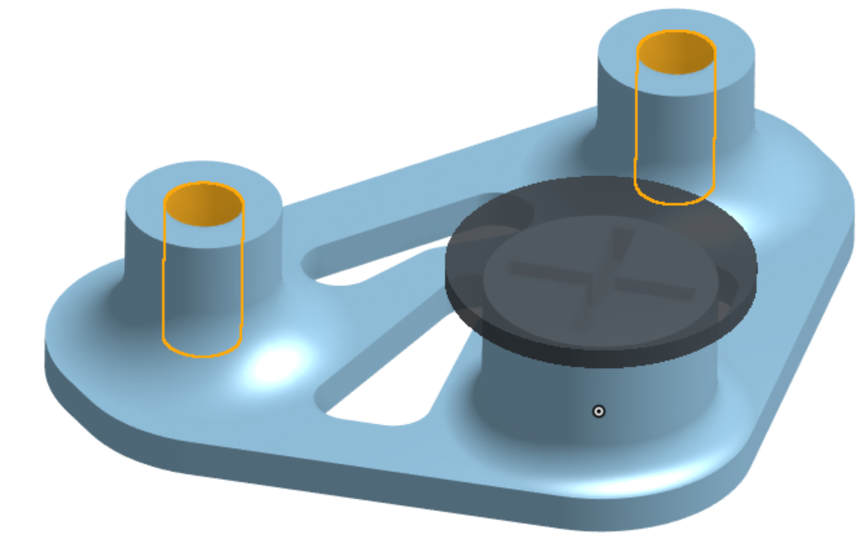

About the Testing Rig

- The Challenge Rig is a single 3D-printed bracket consisting of 2x ¼-inch “mounting holes” and a “coin stand”.
- The overall dimensions of the rig are as follows: 2” (long) x 2.75” (wide) x 0.625” (tall).
- It is recommended that competition host have the rig printed and attached to a flat surface (a piece of lumber or plywood is sufficient). The Contest 2 rules will utilize the flat surface below the rig; so the surface should be at least 12”x12”.
- The files to print these two parts can be found on GrabCAD here:
https://grabcad.com/library/2019-testing-rig-1

SkillsUSA 2019 Additive Manufacturing State Challenge

Quarter Query - Heads to Tails
Schedule of Events

Tuesday April 9, 2019

12:00pm - Orientation (Advisors required to attend)
12:15pm - Submit Engineering Notebooks for Quarter Query Design
12:30pm - On-site Design Challenge (3Hrs)
3:30pm - Design Challenges Submitted
Note: Design Challenges will be printed offsite year at GTCC

Wednesday April 10, 2019

8:00am - Additive Manufacturing Written Test
9:00am - Presentations for Quarter Query Design Challenge
10:30am - On-site Design Challenge - Assembly & Tested
12:00pm - Pack up & Clean up
12:30pm - Debriefing (Mandatory)

