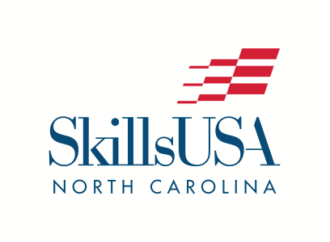
P.O. Box 28064
Raleigh, NC 27611
Phone: (919) 675-1241
SkillsUSAnc@gmail.com

2019 PRESS RELEASE
FOR IMMEDIATE RELEASE

Louisville, KY, June 29, 2019 - NAME, AGE, of CITY, NC, has WON or RANKED and/or received a Skill Point Proficiency Certificate or participated in the SkillsUSA national championship competition in CONTEST. The SkillsUSA Championships, held in Louisville, KY, took place June 24-28, 2019, as part of the 55th SkillsUSA National Leadership and Skills Conference (NLSC), a showcase of career and technical education students. During the week, more than 6,600 outstanding career and technical education students – all state contest winners – competed in over 100 different hands-on trade, technical and leadership fields. 501 North Carolinians from 19 community colleges, 41 high schools, 3 middle schools, and 1 university participated in the SkillsUSA National Leadership and Skills Conference.

FIRST NAME is a GRADE at SCHOOL NAME. [Add a quote here. Example: “We are very proud of John’s accomplishments,” said Sam Smith, John’s advisor at Monroe.] He/She and the other students that participated in the NAME CONTEST competition are true champions in their dedication to excellence in their trade and their leadership skills.

During the national competition, STUDENT NAME and other students worked against the clock and each other, proving their expertise in occupations like electronics, computer-aided drafting, precision machining, medical assisting and culinary arts. All contests are run with the help of industry, trade associations, and labor organizations, and test competencies are set by industry. In addition, leadership contestants demonstrated their skills, which included extemporaneous speaking and conducting meetings by parliamentary procedure.

[Note: for a description of a contest and more information, look at the contest trade release at www.skillsusa.org/events-training/national-leadership-and-skills-conference/press-kit/ under “resources” and add your own description here.]

Top student winners received gold, silver and bronze medallions. Many also received prizes such as tools of their trade and/or scholarships to further their careers and education. The SkillsUSA Championships is for middle school, high school and college-level students who are members of SkillsUSA.

SkillsUSA is a nonprofit partnership of education and industry to strengthen our nation’s skilled workforce. Driven by employer demand, SkillsUSA helps students develop necessary personal and workplace skills along with technical skills grounded in academics. This SkillsUSA Framework empowers every student to succeed at work and in life, while helping to close the “skills gap” in which millions of positions go unfilled. Through SkillsUSA’s championships program and curricula, employers have long ensured schools are teaching relevant technical skills, and with SkillsUSA’s new credentialing process, they can now assess how ready potential employees are for the job. SkillsUSA has more than 360,000 annual members nationwide in high schools, colleges and middle schools, covering over 130 trade, technical and skilled service occupations, and is recognized by the U.S. departments of Education and Labor as integral to career and technical education. For more information: www.skillsusa.org

North Carolina was very well represented in the SkillsUSA Championships, earning a total of 78 medallions (highest total medal count in the nation). Students earned 20 gold medals, 33 silver, and 25 bronze.

Please see the following fact sheet for more details and information regarding the conference.

For more information, visit www.SkillsUSA.org and SkillsUSAnc.org.

###

