2022 SkillsUSA State Competition
Additive Manufacturing
“Mini Train/Car” Design Challenge

Additive Manufacturing Teams will design a “Mini Train/Car” that will fit on the supplied wooden track and have it roll down the 5’ of track with a 90 degree turn.
Materials & Supplies
AM Teams will need to provide the following:
• Prototype
• Thumb drive loaded with 3D design
• Engineering notebook
• Presentation
Materials Provided by Regional Competition Host:
- Track set up
- Table for presentation
- Power source for

Need to Know Information:
- The object of the contest is to produce a protype that has speed and can stay on the track for as long as possible.
- The prototype will be place at the top of the hill and held by one team member until the judges say “Go”.
- Teams will be judged on the following:
  - Prototype Design
  - Engineering Notebook
  - Presentation
  - Distance (reach finish line)
  - Speed
- The device must follow these 3D printing specs measured in Grab CAD Print:
- Print time in less than 2.5 hours
- Has a build volume of no greater than 1.75” x 3” x 2.5 in
- Uses no more than 5 in³ of model material
- Uses no more than 2 in³ of support material

About the Track

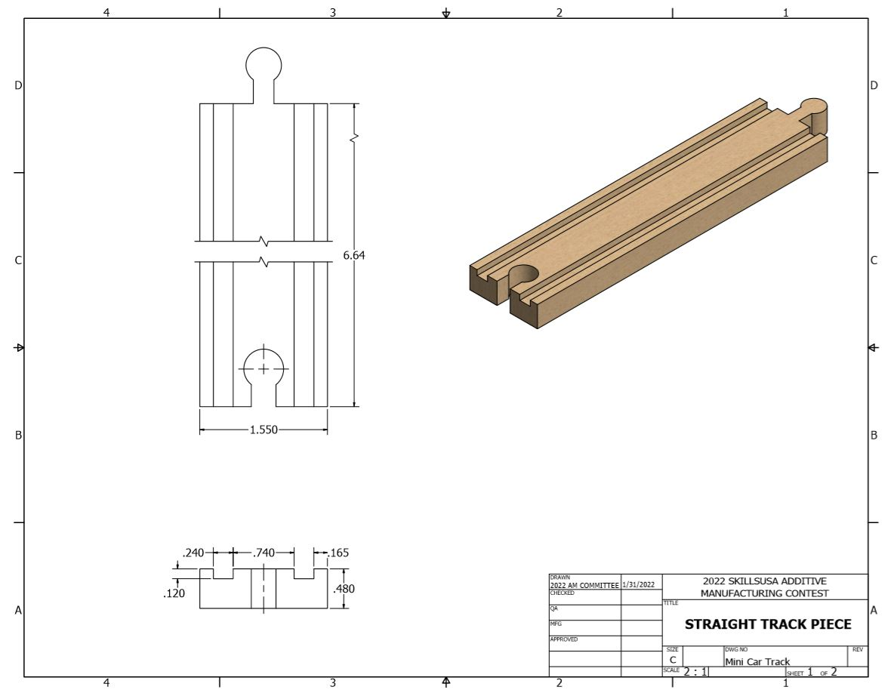
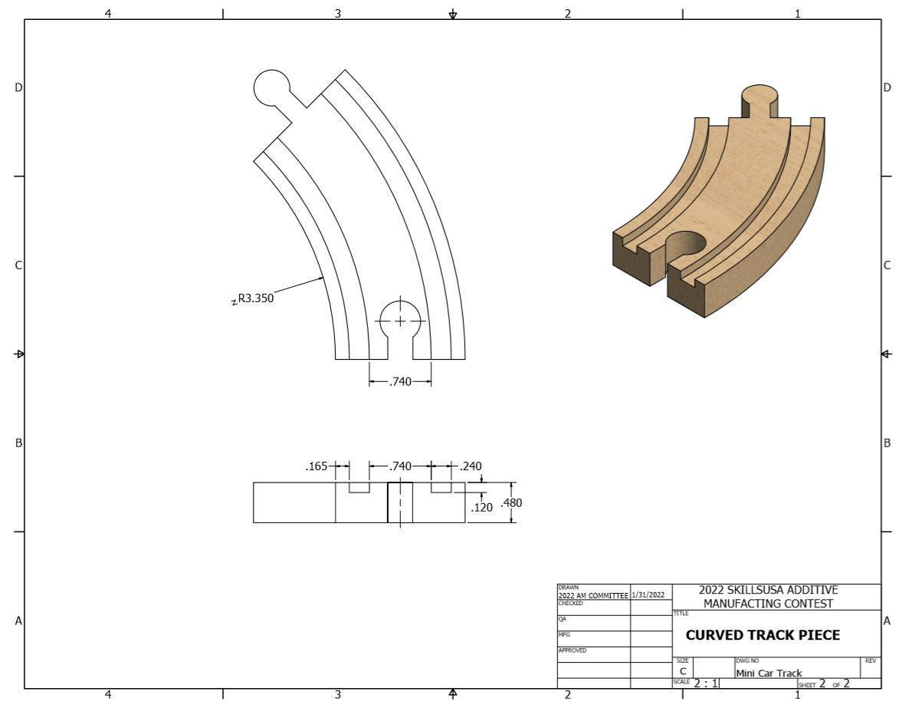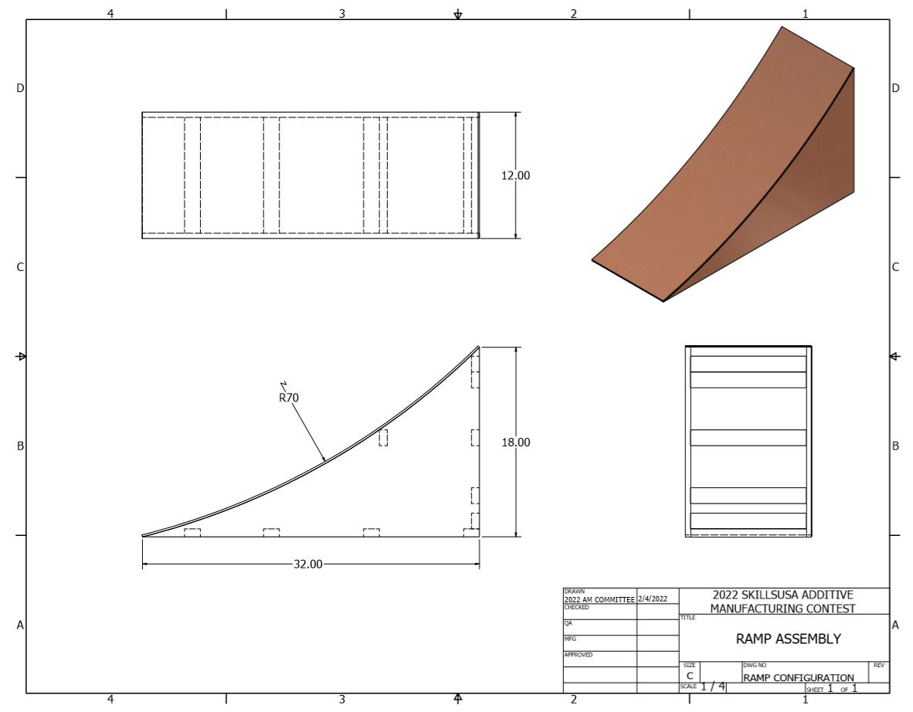

STATE CONTEST SPECIFICATIONS:

Mail Run!
Scenario:
A catcher pouch was a mail bag used by Railway Post Offices of the nineteenth century and the early twentieth century. Its use was limited to exchanges onto moving trains. The specially constructed catcher pouch was grabbed by the catcher mechanism in the passing railway car and the catcher pouch would release from the holding rings on the mail crane. This technique was known as "mail on the fly". Starting in the 1870s the use of this technique of the Railway Mail Service was an important issue in the United States. It was a popular technique and the backbone of the United States Postal Service through the 1930s.

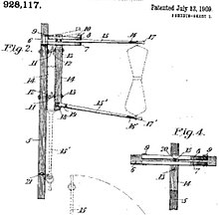

Task:
Teams will need to design, 3D print, and implement a catcher mechanism that attaches to the existing 3D printed prototype design. The “catcher” will need to be able to grab the bag of mail when the train/car passes by and hold onto the Mail bag until the train/car comes to a complete stop.
NOTE: Completed prototype designs must be printed prior to the 2022 State Conference.

Design Modification Specs:
2022 Regional specifications apply for the Train/Car design. See details on page one.
Additional designs for State competition are as follows:
- The catch design must follow these 3D printing specs measured in Grab CAD Print:
- Print time in less than 1.5 hours
- Uses no more than 3 in³ of model material
- Uses no more than 1.5 in³ of support material

2022 State Design Scoring:
- Teams will be judged on the following:
  - Prototype/Design Modifications
  - Engineering Notebook
  - Presentation
  - Catch Mechanism and its ability to complete the task of grabbing the mail and carrying it to the finish line
  - Distance

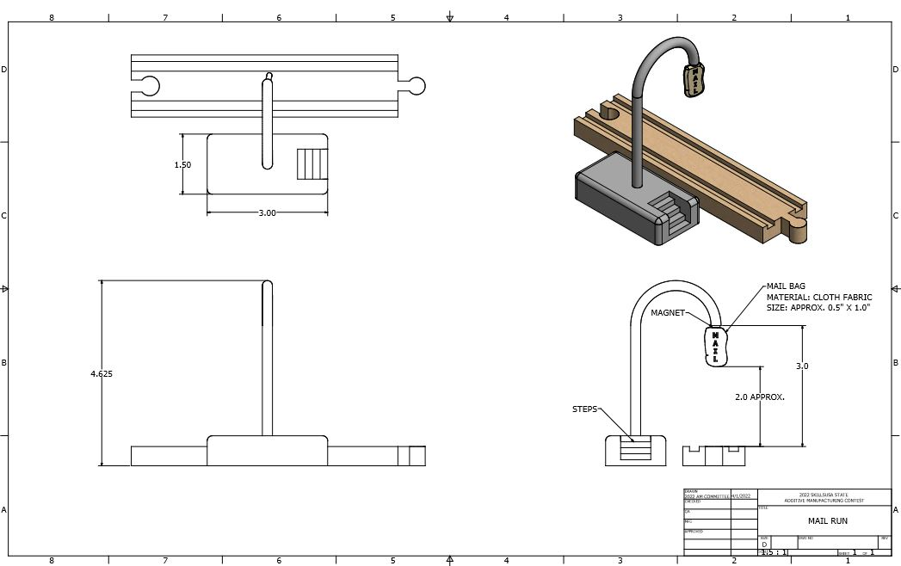

Resource Files:
https://drive.google.com/drive/folders/1OxNnklYeo1RKVTZ1n-XsmuCyx4197SFs?usp=sharing

2022 SkillsUSA State Conference Agenda
Wednesday April 27
12:00 - Orientation
12:15 - Collect Engineering Notebooks
12:30 - Give the Onsite 2022 State Design Challenge
4:00 - Design Challenge ends
- Teams must submit their design to judges via USB drive

Thursday April 28
8:00 - AM Written Test
8:30 - Team Presentations
- Modified Prototypes
- Notebooks
- Test Train/Car with Mail Hook Design
9:45 - Break
10:00 - Onsite 2022 State Design Challenge Testing
- Teams will be given their designs (printed parts)
- Assemble designs
11:00 - Teams will Present their Onsite 2022 State Design Challenge to judges
- Test Designs
12:00 – (Tentative) Competition ends
- Teams are responsible for cleaning up the competition area

