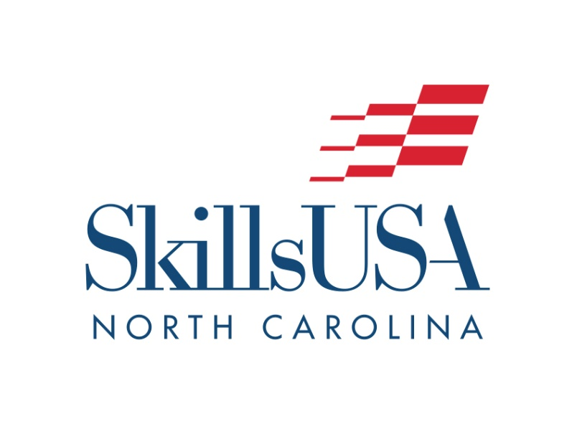

2021 State Fair
Mobile Robotics Contest

October 24th, 2021

- 9:15-9:40 a.m. Contest Registration
- 9:45 a.m. Contest Briefing
- 10:00–11:00 a.m. Mobile Robotics/Engineering Practice Testing
- 11:15 a.m.–1:00 p.m. Mobile Robotics/Engineering Performance
- 1:00 p.m.* Announcement of Winners/Awards Presentation
*Times subject to change based on performance speed & number of teams

Contest Description
Students will work in teams of 2 to design and build a robot to accomplish the tasks outlined on the competition course.
Students will bring their robots assembled and will be given 1 hour to test and make minor changes to their robot if needed.
Following the testing phase, teams will compete in multiple rounds of competition, including autonomous and manual operation modes.

1. Contestants must be high school or middle school students in a related curriculum.
2. Contestants must furnish own equipment, tools, robot & power cords.
3. Robots should be Vex or similar equivalent to Vex.
4. Must have safety glasses and necessary personal protective equipment.
5. Contest limited to the first 20 qualified teams.
6. No Registration Fee!! But you must register in advance. Link to Register.

Registration Deadline – October 15, 2021

Competition Field
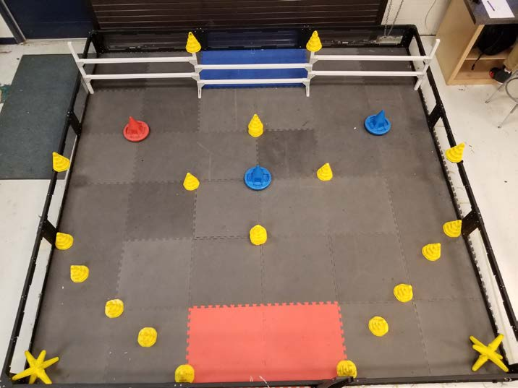

The Game:  This year’s NC State Fair Mobile Robotics challenge is played on a 12’x12’ square field configured as seen above. Teams are tasked with moving stars and cones across the fence line into the scoring zones, as well as strategically picking and placing yellow cones on to red or blue cone shaped goals. The object is to score as many points as possible during a two-minute autonomous and operator controlled round.  The Field:  The field contains 20 yellow cones, 3 mobile Goals, and 2 yellow stars and 1 preload yellow cone. The object is to pick up yellow cones and place them on the red or blue cone shaped goals and/or move the scoring objects into any scoring area on the other side of the fence. The field contains two different scoring zones in regard to the fenced area. One zone consists of a 2’x 4’ rectangle made up of blue tiles. A second scoring zone is located over the fence spanning the playing field. Any scoring objects that are completely inside the fence scoring zone will be scored. Cones or stars pushed under the fence will be scored. |  | The Round:  The competing robot will begin the round positioned completely inside the starting rectangle created by the red floor tiles. For the first 30 seconds of the round, the robot operates completely autonomously. Using sensors and/or preprogrammed instructions, the robot must attempt to strategically either move the scoring objects into any scoring area over the fence or picking and placing yellow cones on to red or blue cone shaped goals. One preload cone will be allowed during the autonomous period. Any points earned during the autonomous will count for twice as much as the remote-control round. During the next 90 seconds of the round, drivers take control of the robot. Teams score points for each scoring object placed inside the scoring zones over the fence and for each yellow cone placed on red or blue cone shaped goals. There will be up to six rounds. This will be determined by the judges on competition day.

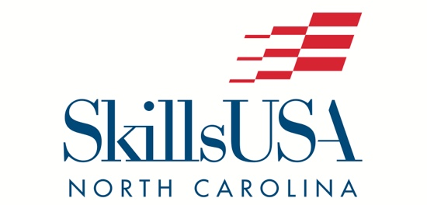

2021 State Fair Contest Robot Kit
VEX Clawbot Kit Components

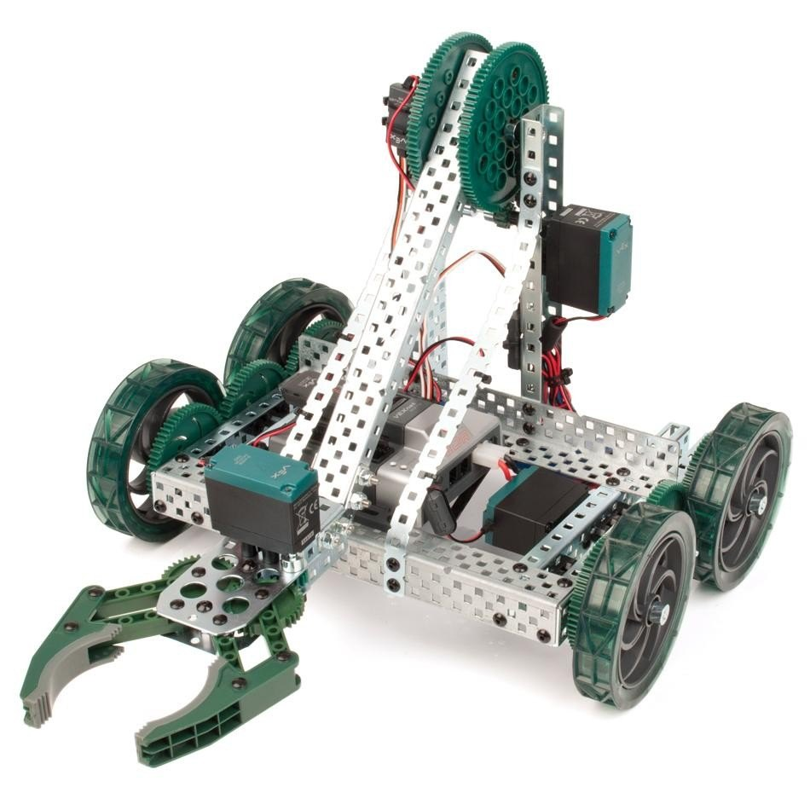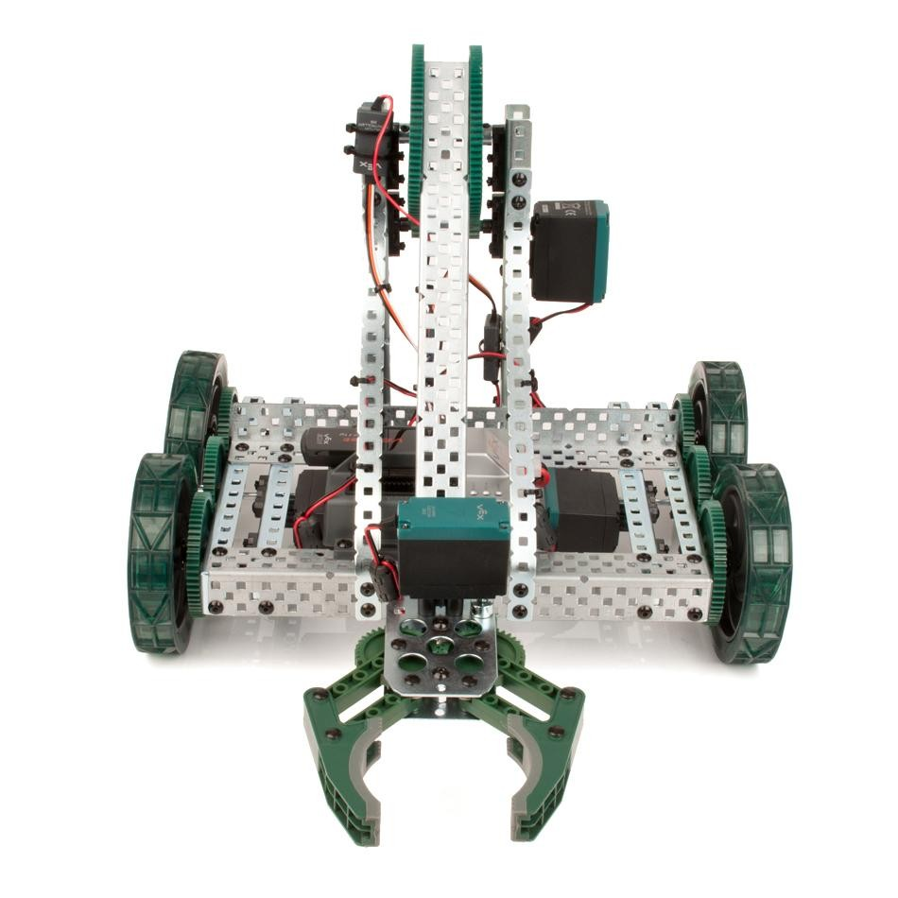
The following components or equivalent may be used.

Motion  (3) 2-Wire Motor 393  (4) 2-Wire Motor 393 High Speed Gear Sets  (1) Claw Kit Assembly (includes motor)  (21) Shaft Collar  (4) Shaft Coupler  (8) Shaft, 3" Long  (18) Bearing Flat  (2) Spur Gear, 12-tooth  (6) Spur Gear, 60-tooth  (2) Spur Gear, 84-tooth  (4) 4" Wheel  Metal  (3) Bar, 20-hole  (3) Chassis Bumper (20-hole)  (6) Chassis Rail (16-hole)  (4) C-Channel, 1x2x1x15 hole  (3) C-Channel, 1x2x1x20 hole | Electrical  (2) Motor Controller 29  (1) Battery Strap (2-pack)  Hardware  (32) Screw, 8-32 x 1/4" Long  (14) Screw, 8-32 x 1/2" Long  (3) Screw, 8-32 x 1 1/2" Long  (6) Locking Screw, 6-32 x 1/4" Long  (6) Locking Screw, 6-32 x 1/2" Long  (42) Nut, 8-32 Keps  (2) Nut, 8-32 Nylock  (6) Shaft Spacer, Thin (4.6mm)  (50) 4" Tie Wraps  (32) Bearing Attachment Rivet  (1) Standoff 1.00"  Equipment  (2) Tool, Hex Key (5/64")  (2) Tool, Hex Key (3/32")  (2) Tool, VEX Open-Ended Wrench

SkillsUSA North Carolina

CONSENT AND RELEASE FORMS
By checking the “attest” box at the bottom of the online registration form, every attendee/parent/ guardian agrees to the Code of Conduct, Photography and Sound Release, and Medical Consent conditions outlined below. Checking the “attest” box also indicates parental permission for the student to attend the event if the student is under 18. By checking this box, we have the understanding that you have informed the parents of the activities the student will be participating in and that they are aware of the information listed below. If the “attest” box is not checked, the student will not be allowed to attend the conference and participate. Also, all medical, insurance, and parental contact information need to be filled out completely online. The information below should be sent home to the parents of your students so they are aware of what they are agreeing to.

PERSONAL LIABILITY RELEASE
As a parent/guardian/Individual, I hereby agree to release SkillsUSA Inc. North Carolina, its representatives, agents, servants, and employees from liability for any injury to the named person resulting from any cause whatsoever occurring to the named person at any time while attending a SkillsUSA North Carolina function, including travel to and from the conference. I voluntarily assume all risk and danger relating to the conference, whether occurring prior to, during or after the event.
I do voluntarily authorize SkillsUSA Inc. North Carolina and its designees to administer and/or obtain routine or emergency diagnostic procedures and/or routine emergency medical treatment for the named person as deemed necessary in medical judgment. Parents/guardians of participant will allow emergency medical treatment to be administered as needed.
I agree to indemnify and hold harmless SkillsUSA Inc. North Carolina and said designees for any and all claims, demands, actions, rights of action, and/or judgments by or on behalf of the named person arising from or on account of said procedures and/or treatment rendered in good faith and according to accepted medical standards.

MEDICAL CONSENT
It is understood that the student will be chaperoned both while traveling to and during the SkillsUSA North Carolina State conference by his/her local SkillsUSA advisor(s), and that normal precautions will be taken in the interest of his or her safety and well-being.
We agree that the SkillsUSA North Carolina State Association, State Staff, or their designee(s) will not be held responsible for any accident or injury, which might occur in connection with the SkillsUSA North Carolina State Conference.
We also give consent to SkillsUSA North Carolina for medical treatment in case of an emergency requiring a doctor’s care and/or hospitalization, and provide you with the pertinent medical information.

PHOTOGRAPHY AND SOUND RELEASE
I hereby grant SkillsUSA North Carolina permission to make still or motion pictures and sound recordings, and also give a production company approved by SkillsUSA North Carolina permission to use the finished silent or sound pictures and/or sound recordings as deemed proper.
Further, I so hereby relinquish to the SkillsUSA North Carolina all rights, title, interest, and income from the finished sound or silent motion pictures, still pictures, and/or sound recordings, negatives, print, reproductions, and copies of the originals, negatives, recording duplicates and prints, and further grant SkillsUSA North Carolina the right to give, sell, transfer, and/or exhibit the same to any individual business firm, publication, television station, radio station or network; or government agency, or to any of their assignees, without any payment or consideration to me.
My agreement to perform under camera, lighting, and stage conditions is voluntary and I do hereby waive all personal claims, causes of action, or damages against SkillsUSA North Carolina and the employees thereof, arising from a performance or appearance.

