Roofing (Thermoplastic) SkillsUSa
Technical Specifications

Version 2.0 8/11/22
Thermoplastic roofing knowledge and skill assessment
Purpose
To develop and recognize the contestant’s thermoplastic roofing skill competency and to encourage further advancement in this discipline.

Additionally, download and review the General Regulations at: http://updates.skillsusa.org.

Clothing Requirements
Class C: Contest Specific — Manufacturing/Construction Khaki Attire
- Official SkillsUSA khaki short-sleeve work shirt and pants.
- Black, brown or tan leather work shoes.

Note: Safety glasses must have side shields or goggles (prescription glasses may be used only if they are equipped with side shields. If not, they must be covered with goggles).

These regulations refer to clothing items that are pictured and described at: www.skillsusastore.org. If you have questions about clothing or other logo items, call 1-888-501-2183.

Note: Contestants must wear their official contest clothing to the contest orientation meeting.

Safety Requirements
The contest committee is responsible for the health and safety conditions of the venue. The contestant is responsible for adhering to the prerequisite safety protocols and evidenced by satisfactorily passing the contest’s safety exam. In addition to passing the written exam the contestant is required to demonstrate the skills at the beginning of the timed exam event.
- Inspection of the work surface for visible deficiencies
- Inspection of personal hand tools
- Inspection and verbal description of the personal fall arrest system
- Donning the personal fall arrest system
Release
The instructor and the contestant each agree that SkillsUSA Inc., the SkillsUSA Championships technical committee and national judges are released from all responsibility and liability relating to personal
injuries resulting from these activities. Contestants will be removed from competition if proper safety protocols cannot be demonstrated and maintained throughout the timed examination.

Equipment
- Supplied by the contest committee
  - Personal Fall Arrest System
    - Body harness with dorsal d-ring, (no hip or side d-rings allowed)
    - Shock absorbing lanyard 3’
    - Line, 25’
    - Rope grab
    - Anchor
  - Thermoplastic exam mockup, per National Roofing Contractors Association, NRCA, design.
  - All materials as identified on the contestant specification document
  - Written contestant specifications.
  - Tools and equipment
    - Hand tools
      - Tape measure, 25-foot
      - Chalk line
      - Black marker
      - Utility knife, w/hook and straight blades, retractable
      - Utility saw, hand-held for insulation
      - Hammer, claw
      - Screwdriver, Philips and flat
      - Wrench, adjustable (8” to 10”)
      - 2” silicone or Teflon seam roller
      - Seam Probe
      - Shears (10” blade recommended)
      - Metal snips (straight or articulated)
      - 36” wide soft bristle push broom
      - Paint brush, 3” (disposable chip-brush for adhesive)
      - Cotton rags, clean and white (for membrane cleaning and general housekeeping)
    - Power tools
      - Power supply cord (UL approved, type SG or SJO heavy duty, to match power tools and distance to power source
      - 20-amp power supply with ground fault interruption circuitry
      - Hand-held hot-air welder, min 1600 watt with manual temperature range up to 1,200°f.
        - 40mm 22° welding nozzle
        - 20mm welding nozzle
        - 1 ½” wire brush, brass
        - Spare heat filament for hot-air gun (or backup hot-air gun)
      - Variable speed screw gun/driver
        - ¼” hex bit
        - #3 Phillips bit

- Supplied by contestant
    - Safety glasses or goggles, Z-87 rated, with side guard splash protection
    - Hand protection, inclusive
      - Leather gloves, general hand protection from heat source
      - Utility cut-resistant gloves, Kevlar or other comparable materials
      - Chemical resistant as prescribed by Safety Data Sheet, SDS, requirement (typically nitrile)
      - Leather work shoes: brown, black, or tan
    - Tool belt (recommend minimum two pouch with hammer loop)
Material and Supplies (sufficient for one examination on the illustrated mockup below)
10 | Lineal feet | Minimum 0.073-inch-thick by 1-inch-wide extruded aluminum termination bar with caulking lip | 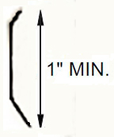
120 | Square Feet | Minimum 45-mil-thick by 60-inch-wide reinforced TPO or PVC membrane roll | ASTM D 6878 or ASTM D 4434
30 | Square Feet | Minimum 45-mil-thick by 18-inch-wide reinforced or nonreinforced TPO or PVC flashing membrane | ASTM D 6878 as required by system manufacturer
5 | Pieces | Pre-molded outside corners | Provided by system manufacturer, for parapet wall and curb flashing outside corners
5 | Pieces | T-joint covers | Provided by system manufacturer, for t-joints
50 | Pieces | Field membrane seam fasteners and plates | Length and type as required by system manufacturer, job-site requirements with consideration for thickness of insulation
50 | Pieces | Insulation fasteners and plates.
50 | Pieces | Cap nail fasteners | Optional membrane attachment at curbs or perimeters. Length and type as required by system manufacturer and available mockup conditions.
25 | Each | 1 ¼-inch corrosion-resistant self-piercing pancake- or round-head screw fasteners | ASTM A153 fasteners for attaching termination bar
1 | Gallon | Membrane cleaner solution | As required by the system manufacturer
1 | Gallon | Flashing sheet bonding adhesive | Compatible bonding adhesive as required by the system manufacturer. This is typically the same adhesive used to bond field sheets. System manufacturer specifications or available mockup conditions may require additional adhesive.
1 | Each | Prefabricated pipe boot flashing, including draw band | As required by system manufacturer
3 | Sheet | 4’X8’ rigid board insulation 1” thickness min. | Typically faced polyisocyanurate insulation,

Thermoplastic Mockup
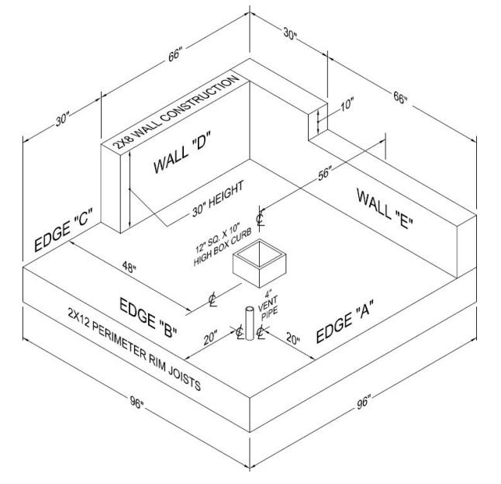

SCOPE OF THE CONTEST

Thermoplastic Roofing Knowledge Exam
The contest will include the successful completion of a thermoplastic roofing knowledge exam arising from the TRAC Thermoplastic course. This will assess the contestant’s knowledge of roofing including, but not limited to, weatherproofing, seams, flashing, roof system components, and structural elements of roofs.

Skill Performance
The thermoplastic skills will be performed on an NRCA designed mockup. The installation will comply with accepted national benchmarks. Contestants will be given detailed written specifications to install a functional thermoplastic single-ply membrane system.

Contest Guidelines
- 4-hour time limit.
- Initial demonstration of personal fall arrest system inspection and donning
- Remains compliant with safety or work stops until remedied, while clock continues to run
Standards and Competencies
- Compliance – Reads specifications to provide a compliant installation regarding fastening patterns, spacing, seaming, flashing, drainage, and safety protocols
  - Complies with written specifications but free to determine sequences
  - Complies with standard safety protocols
  - Complies with power tool operation manual
- Preparation - Readies the deck, materials, and work area for the commencement of installation
  - Visually inspects the deck and structure to assure conditions meet anticipated requirements for work
  - Determines roof drainage direction, field area, vertical surfaces, penetrations, and flashing requirements
  - Develops installation sequences for assignment
  - Confirms necessary components are present along with the necessary quantity and condition of materials
  - Inspects all tools
- Sequence – Establishes a plan to complete the specification within the competition parameters
  - Cross references instructions, materials, tools, and mockup
  - Develops a sequence for installation
  - Organizes tools and materials to support sequence within the allotted time.
- Insulation – Measures, cuts, and fits rigid board insulation according to specification
  - Determines appropriate insulation board surface to interface with roof system
  - Trims boards to install in largest sizes possible within joint-gap tolerances
  - Complies with staggered joint principles
  - Mechanically attaches rigid board to deck according to required fastening patterns
- Field - Measures, cuts, and fits the field membrane sheets according to specification
  - Lays field sheet to accommodate drainage direction
  - Provides field membrane extension up vertical surfaces
  - Establishes appropriate side- and end-lap sizing
  - Creates a splice cut as needed
  - Creates flashing flanges for vertical curb flashing sheet
  - Mechanically attaches sheet with required fasteners. Complies with specification fastening patterns
- Hot-air Welding – operates the hot-air welder to create weatherproof seams and splices.
  - Selects and affixes appropriate nozzle.
  - Powers up hot-air welder and conducts test welds to determine appropriate welding temperature
  - Calibrates operational temperatures, creates test samples, records date, and temperature
  - Cleans all surfaces for welding with specified membrane cleaner
  - Creates 1 ½” to 2” fully bonded thermoplastic welds by coordination of welder, 2” roller, and body mechanics
  - Probes all welds upon membrane cooling
  - Monitors nozzle for contamination and cleans appropriately
- Flashing - Fortifies roof transitions at curbs, walls, penetrations, t-joints, inside corners, and outside corners
  - Measure, cuts, fits, flashing membrane and manufactured accessories to fit all transition types
  - Rounds all exposed corners
  - Provides appropriate overlap
  - Complies with drainage pattern
  - Cleans all flashing materials and areas
  - Hot-air welds each as required by specification
  - Adheres flashing membrane to verticals surfaces as specified
- Sealants –Sealants are critical to a weatherproof thermoplastic roof system; however their use is not practical in this competition. Therefore, all candidates will inform their instructors as to when, where, and the specific type each time a sealant is required. Omission will result in a loss of points.
- Housekeeping – maintains a work area and roof surface which promotes the quality and productivity of the process
  - Protects roofing membrane surfaces from cuts, abrasion, and contamination during the installation.
  - Keeps tools and materials in accessible locations and out of the direct work area
  - Keeps waste and debris collected and out of the direct work area
Committee Identified Academic Skills
The technical committee has identified that the following academic skills are embedded in this contest.

Math Skills
- Use fractions to solve practical problems.
- Use proportions and ratios to solve practical problems.
- Measure angles.
- Find surface area and perimeter of two-dimensional objects.
- Apply transformations (rotate or turn, reflect or flip, translate or slide, and dilate or scale) to geometric figures.
- Construct three-dimensional models.
- Apply Pythagorean Theorem.
- Make comparisons, predictions and inferences using graphs and charts.
- Find slope of a line.
- Solve practical problems involving complementary, supplementary and congruent angles.
- Solve problems involving symmetry and transformation.

Science Skills
- Use knowledge of work, force, mechanical advantage, efficiency and power.
- Use knowledge of simple machines, compound machines, powered vehicles, rockets and restraining devices.

Language Arts Skills
- Provide information in conversations and in group discussions.
- Provide information in oral presentations.
- Demonstrate use of such nonverbal communication skills as eye contact, posture and gestures using interviewing techniques to gain information.
- Demonstrate comprehension of a variety of informational texts.
- Use text structures to aid comprehension.
- Identify words and phrases that signal an author’s organizational pattern to aid comprehension.
- Understand source, viewpoint, and purpose of texts.

Connections to National Standards
State-level academic curriculum specialists identified the following connections to national academic standards.

Math Standards
- Numbers and operations.
- Geometry.
- Measurement.
- Data analysis and probability.
- Problem solving.
- Communication.
- Connections.
- Representation.
Source: NCTM Principles and Standards for School Mathematics. For more information, visit: http://www.nctm.org.

Science Standards
- Understands the structure and function of cells and organisms.
- Understands relationships among organisms and their physical environment.
- Understands the sources and properties of energy.
- Understands forces and motion.
- Understands the nature of scientific inquiry.
Source: McREL compendium of national science standards. To view and search the compendium, visit:
www2.mcrel.org/compendium/browse.asp.

Language Arts Standards
- Students adjust their use of spoken, written, and visual language (e.g., conventions, style, vocabulary) to communicate effectively with a variety of audiences and for different purposes.
- Students use a variety of technological and information resources (e.g., libraries, databases, computer networks, video) to gather and synthesize information and to create and communicate knowledge.
Source: IRA/NCTE Standards for the English Language Arts. To view the standards, visit: www.ncte.org/standards.

