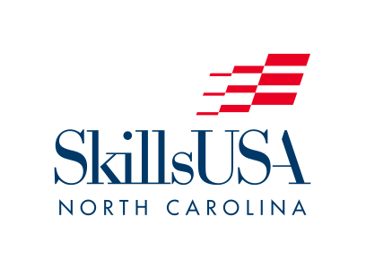

PO Box 28064
Raleigh, NC 27611
Office: (919) 675-1241
Email: Info@SkillsUSAnc.org

2022 National Leadership and Skills Conference Registration

The Annual National Leadership & Skills Conference, Atlanta, Georgia, June 20-25, 2022.
Arrive by 7:00 PM on Monday, June 20. Depart on Saturday, June 25.

To download the complete National SkillsUSA Conference packet for NC –
go to SkillsUSAnc.org

Registration Deadline: May 13, 2022. NO EXCEPTIONS. Complete your NLSC registration online on the SkillsUSA national web site at Register.SkillsUSA.org. Registration packets and details, including hotel information, can be found at SkillsUSAnc.org. All persons attending any part of the National Conference MUST register with SkillsUSA North Carolina through the national website to receive insurance coverage.

Registration Fee - $300. Online Registration is due by May 13, and payment must be received by May 13. Any drops after May 13 are non-refundable.
**SkillsUSA’s New Policy: ALL NLSC EVENTS ARE CLOSED TO THE GENERAL PUBLIC AND WILL REQUIRE A NAME BADGE. ONLY REGISTERED ATTENDEES WITH NAME BADGES WILL BE ABLE TO ACCESS NLSC EVENTS, INCLUDING THE COMPETITION FLOOR. Everyone attending must register.

Travel: North Carolina has arranged charter buses to/from the national conference to the Marriott Marquis Downtown Atlanta for $200 round-trip. Those traveling by air should check on and secure ground transportation to/from the airport. Bus seats are allotted on a first come/first serve basis and are non-refundable after May 13.

Arrival: The North Carolina Delegation will have an opening meeting on Monday, June 20, at 8:00 pm. This meeting will be for pick-up of registration materials and name tags, AND communicating other vital national conference information. EVERYONE NEEDS TO ATTEND.

Lodging: North Carolina delegation is required to stay at the Marriott Marquis Downtown Atlanta - 265 Peachtree Center Ave NE, Atlanta. All North Carolina attendees must book their room through SkillsUSA North Carolina.

Room rate (5 nights, King/Double) – $1150/$1275. (Breakfast Not Included.)
Room Payment is due by May 13. Additional room nights are available if you desire to arrive early or depart late at a nightly rate of $230/$255.

Student and Advisor Training: Saturday, June 18 - Monday, June 20: Students and advisors are invited to participate in ACTIVATE and ENGAGE, top-notch student and advisor training. The cost is $165 per person plus additional nights lodging. Check online for more details.

