ESTHETICS 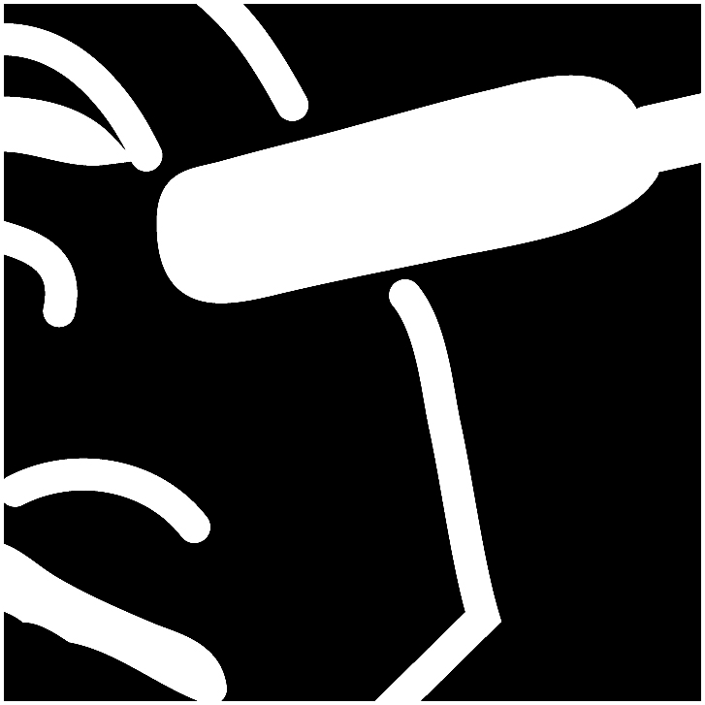
North Carolina

PURPOSE
To evaluate each contestant’s preparation for employment and to recognize outstanding students for excellence and professionalism in the field of esthetics.
First, download and review the General Regulations at: updates.skillsusa.org.

ELIGIBILITY
Open to active SkillsUSA members enrolled in programs with cosmetology/esthetics as the occupational objective.

CLOTHING REQUIREMENT
CONTESTANT: White Polo shirt, Black Dress Slacks (no jeggings or leggings, no spandex, no yoga pants, no skin-tight pants, no denim), Black belt with no ornamentation (if slacks have belt loops), Black dress socks or black or skin-tone hose is allowed under slacks, Black leather work shoes (closed toe).
No jewelry or watches (excluding wedding bands)
Smock (Optional): Contestants may wear a white smock.
If students show up in attire that is unprofessional, they are not allowed to compete.

MODEL: Solid Black Round neck (crew) shell/shirt, Black Dress Slacks (no jeggings or leggings, no spandex, no yoga pants, no skin-tight pants, no denim), Black belt with no ornamentation (if slacks have belt loops), Black dress socks or black or skin-tone hose is allowed under slacks, Black leather work shoes (closed toe).
No jewelry or watches (excluding wedding bands)

EQUIPMENT AND MATERIALS
- Supplied by the technical committee:
  - Tables (for use in performance of facials)
  - Chairs (for models)
  - Small table for products
  - Towel steamers
  - Water
  - Bowls
  - First Aid Kit and Blood Spill Kit

Supplied by contestant:
  - Models: must be student members dressed appropriately as described in the required clothing statement; must maintain hair pulled away from the face; must have a clean, cosmetic-free face; and must not wear earrings, facial piercings or necklaces (jewelry may be worn in the fantasy portion of the contest). Models are not required to take the Professional Development Test or the skill-related written test or to submit a résumé.
  - A written description of the theme for the fantasy makeup portion of the contestant’s theme interpretation is limited to one page typewritten in a legible font and contained within a plastic sleeve. The description must be submitted at the contestant orientation. No exceptions; late descriptions will result in a 10-point deduction.
  - Portable kit organizer (to transport and store items needed during the contest)
  - Esthetic kit check must be in original packaging
  - All items necessary for daytime makeup application
  - All items necessary for basic facial and massage skills including:
- Cleanser
- Exfoliator
- Mask
- Toner or freshener
- Moisturizer
  - All items necessary for basic facial and massage:
    - Cleanser
    - Toner
    - Moisturizer
    - Exfoliator
    - Mask and massage cream

  - All necessary product applicators such as:
- Spatulas
- Cotton swabs
- Fan and mask brushes
- Cotton 4x4 pads or sponges
- Tissues
- Mascara wand
- Makeup brushes
All applicators must be disposable or sanitized.

  - False eyelashes
- Adhesives
- Lash application tools
•Alcohol wipes and sanitizers
  - Minimum of six clean, white terry cloth towels in standard salon size (no holes or stains). For beauty portion contestants can use set-up sheets/paper towels. Contestants will donate two towels to the contest to put in hot towel steamer.
  - Headband
  - Proper draping supplies (cape for makeup application and one fitted and one flat white, clean, twin-size sheet for massage and facial skills)
  - Sealable plastic bags for sanitation and soiled linens (large zip-lock bags are recommended that fit linens and towels)
  - Latex-free gloves (at least two pair)
  - Paper towels or tissues (can be mini travel size)
  - Decontamination supplies for hands, equipment and implements (must be EPA approved, e.g., (but not limited to) Barbicide, Utronics, Clorox wipe
  - Stainless steel bowl for water (1½ quart minimum size)
  - Straight Linens (for beds)
  - Note Pad (for Oral Communications Segment)

Note: All products to be in contact with the skin must be in original manufacturer’s packaging.

GENERAL CONTEST INFORMATION

- Resume – All contestants will be required to turn in during orientation a typed, 1-page, professional resume.

- Talking – No talking to other contestants, instructors, or audience members during the competition is allowed. Doing so may result in disqualification. If you have a question, raise your hand and a sage or the competition chairperson will see to your needs.

- Breaks – Breaks will be given during competition. Contestants are not allowed to leave the area except with a chaperone for restroom visits or emergencies. If contestant gets sick during the competition and need to leave the contest area, no extra time will be allotted.

- Work Time – You can begin the contest when the chairperson signals so and you must stop when time is called. Continuing to work will result in point deductions. All contestants must participate in all phases of the competition, including written (if applicable) and Oral Communications.

- Sanitation – Contestant must disinfect and clean-up their work station/area, which includes a total breakdown of their work station/area. 1 Trash Bag is required, no labeling needed. THIS IS NOT STATE BOARD SANITATION – Just what we are requiring for this competition. Sanitation for this contest includes –
- Sanitizing the workspace at the beginning,
- Sanitizing the workspace at the end,
- Items are not thrown on the floor throughout the competition, and
- All used items go in the trash bag.

- Secondary contestants will compete against secondary and postsecondary will only compete against postsecondary.

- JUDGES DECISIONS ARE FINAL

SCOPE OF THE CONTEST
The contest will include a written esthetic knowledge examination, an oral communications assessment and four skill performance tasks.

Knowledge Performance
The contest will include a skill-related written knowledge test of 50 multiple-choice questions assessing knowledge of esthetics. Contestants will have 30 minutes to complete the exam.
The test bank is from Milady Standard Fundamentals.

Skill Performance
An oral communication portion of the contest will assess the verbal presentation skills of the contestant. The technical skill performance tasks will assess skills in facial massage, basic facial, beauty and fantasy makeup application at multiple performance stations. Creativity is assessed in the fantasy makeup application, while technique is scored in the performance of massage, basic facial and beauty makeup application. An emphasis on safety and sanitation will be used in all segments of the skill performance areas. Observations during each segment and evaluation of the finished product will be considered in the scoring.

Contest Guidelines
- The contest rules will be reviewed at the scheduled orientation. It is not necessary to bring kits to orientation. Following the orientation, contestants will be required to be dressed in official contest clothing, complete the kit check, take the written esthetics knowledge test, and submit the contestant résumé and written theme character and interpretation for the fantasy makeup application.
Note: A résumé not turned in will result in a penalty.
- All contestants must keep their working area clean and organized.
- All contestants must follow sanitation and safety procedures throughout the contest at all times. See EST1.0 below. Floor monitors/judges will assess decontamination procedures and safety practices throughout the contest.
- All contestants must bring a model for the competition. Models are not required to attend the orientation.
  - Contestants must have natural nails (short and not artificial) with no nail polish. Hair must be pulled back; no jewelry or facial piercings. (Penalty will result if these rules are not followed.)
- Contestants will prepare and perform an oral communication presentation. This will consist of a two- to three-minute oral presentation of the contestant’s interpretation and/or the approach to the yearly theme for the fantasy make-up application.
- There will NOT be a written test for North Carolina State competition.
- Penalty points can occur for the following:
  - Any rule not followed, with no exceptions
  - Leaving the competition area before completion of task (applies to both contestant and model) without proper escort
  - Unauthorized use of a product that is not allowed or that doesn’t appear in the above listing
  - Any product that appears to have been altered. All products and solutions must be properly identified with the manufacturer’s original packaging and original labeling. Product labels cannot be defaced.
- Professional attitude and communication is expected throughout the contest
- Once time is called, the contestant must stop working. Touching the model after time is called will result in three penalty points.
- Cellphones are not allowed in contest area. If models and/or contestants are seen with a cellphone, points will be deducted.
- Setup can only consist of items needed for the specific task in progress. Time will be allowed between each task to reset the table. All items should be brought to the contest site organized by task.
- Required implements and products must be accounted for and professionally organized. Proper control and usage of products and tools will be expected at all times.
- Props such as hair ornaments, wigs and jewelry may be used in the fantasy section but will not be considered in the judging. The chair will give contestants time to add final props to the fantasy portion after judging is complete. DO NOT ADD THESE UNTIL JUDGING IS COMPLETED.
- All products used in any portion of the skill contests must be considered safe for application to the skin. This includes any item used on or attached to the skin in the fantasy makeup application.
- Conversation between contestant and model is limited. Any form of communication with observers, judges and other contestants is prohibited during the contest.

Standards and Competencies

EST 1.0 — Setup and Client Protection — judged in all areas of contest (basic facial, beauty and fantasy makeup; 5-minute time limit)
  - Sanitize hands
  - Disinfect work area or uses protective covering
  - Set up work area with supplies clearly labeled
  - No cross contamination of products to skin or skin to product
  - Disinfect or cover chair
  - Dispose of soiled materials using infection control procedures
  - Re-sanitize hands
  - Apply body drape or cover for protection
  - Apply hair drape or cover
  - Re-sanitize hands

EST 2.0 — Cleansing the Face (15 minutes)
  - Preparation
  - Remove cleanser from container using infection control procedures
  - Demonstration of cleansing the face
    - Cleanse the lips safely
    - Cleanse eye area safely
    - Distribute cleanser over entire face safely
    - Cleanse entire face safely (cleansing massage only)
    - Demonstration of massaging the face
      - Distribute massage product over entire face safely
      - Demonstrate effleurage movement
      - Demonstrate petrissage movement
      - Demonstrate tapotement movement
      - Demonstrate friction movement/vibration movement
      - Maintain continuous contact during massage
    - Remove massage product without dragging or pulling skin
    - Remove all residual cleansing massage product safely

EST 3.0 — Basic Facial (consisting of exfoliation, steaming, facial mask, toner and moisturizer; 30 minutes)
  - Exfoliation
    - Remove exfoliation product from container using infection control procedures
    - Demonstration of exfoliation application to the skin
    - Safe manipulation of exfoliation product
    - Removal of exfoliation product from the skin
    - Practice safety and infection control throughout exfoliation procedure
  - Steaming
    - Preparation for steaming of the face
    - Wring wet towels thoroughly
    - Test towel temperature on wrist safely
    - Demonstration of steaming the face
    - Drape towel to cover the face so nose and/or mouth are uncovered
    - Lift towel from face safely
    - Practice safety and infection control throughout steaming procedure
  - Facial Mask
    - Preparation for facial mask
    - Remove mask product from container using infection control procedures
    - Demonstration of facial mask
    - Apply mask product over entire face safely, excluding eyes, lips and nasal passages
    - Apply mask evenly and safely
    - Remove all residual mask product safely
    - Practice safety and infection control procedures throughout service
  - Apply toner or astringent safely
  - Apply moisturizer safely
  - Infection Control
    - Dispose of soiled materials using infection control procedures
    - Practice infection control procedures safely throughout service
    - Maintain work area in a safe manner throughout service

EST 4.0 —Makeup (beauty makeup application – 60 minutes)
  - Preparation
    - All items necessary for daytime makeup and application must be in original packaging.
    - Protect clothing with protective covering or cape
    - Secure hair off face
    - Sanitize hands
  - Demonstration of facial beauty makeup
    - Apply primer/moisturizer to face
    - Apply foundation and concealer to enhance and balance the face
    - Apply powder
    - Apply eye shadow
    - Apply eyeliner (no liquid liners allowed)
    - Apply mascara to lashes
    - Groom eyebrows using shadow brow or brow pencil
    - Apply lip liner
    - Apply lip color
    - Apply makeup without lines of demarcation to have the face match the rest of the body in shade and even toned
  - Safety and Infection Control
    - Dispose of soiled materials using infection control procedures
    - Practice infection control procedures safely throughout service

    - Maintain work area in a safe manner throughout service

Note: Time is not provided to remove beauty makeup; product removal may be done during the scheduled break time at the contest site.

EST 5.0 — Fantasy Makeup (60 minutes). A general theme is provided. Each contestant can choose character or inspiration from the theme.
  - Preparation
    - All items for fantasy makeup application must be in original packaging.
    - Protect shoulders with protective covering or a cape
    - Sanitize hands
  - Demonstration of facial fantasy makeup
    - Proper application of all necessary fantasy make up products
    - Creativity while staying within the theme
    - Completed look — impact of change
  - Safety and infection control
    - Dispose of soiled materials using infection control procedures
    - Practice infection control procedures safely throughout service
    - Maintain work area in a safe manner throughout service

EST 6.0 — Apply the knowledge and skills necessary for professional communication.
  - Professional oral communication
  - Present oral communication to judges
  - Maintain a professional attitude
  - Use eye contact
  - Voice is used appropriately, including volume
  - Professional terminology is used, including grammar
  - Organization of thoughts exhibits flow

