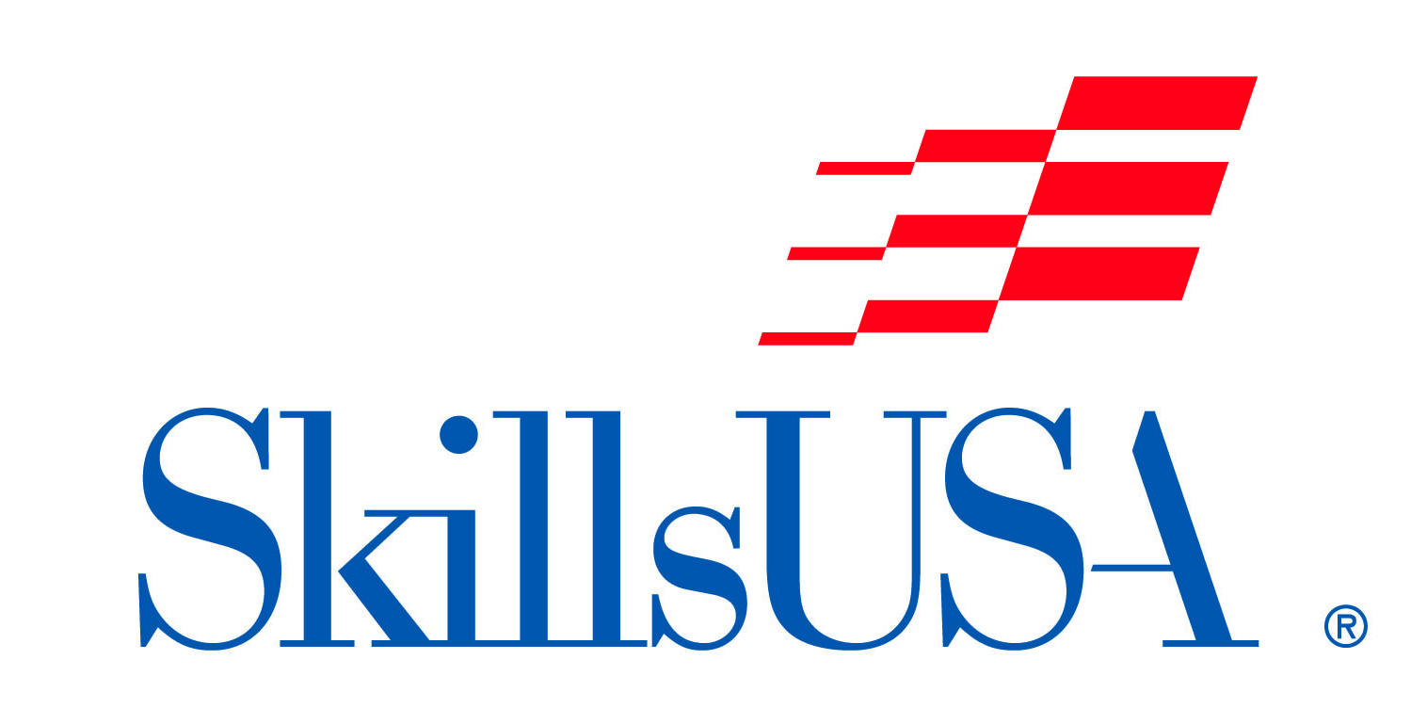
“TOTAL LOOK” (FANTASY HAIR & MAKE-UP)
Student Competition

Date/Time: Saturday, October 22, 2022
Check-in 8:00-9:00am.
Location: NC State Fair Grounds, Raleigh, NC.
Entry Fee: $20 per contestant (models no charge)

The “Fantasy Hair/Make-up Total Look” Student Competition is open to all NC Cosmetology students. NC- Skills USA membership is not required to compete.

Registration Instructions:
Please complete the form online at: skillsusanc.org/state-fair-events

Contest Regulations:
Model & Contestant
- Presentation must be performed on a live model.
- Each entry will have ONE contestant performing all hair and make-up on ONE model
- Models may not apply their own make-up.
- The same contestant must apply make-up and perform the hair design on the model. There will be no switching of contestants during the contest.

Application, Styling, and Props
- 2022 Fantasy theme and costume – DISNEY.
- Hair may be roller set, pin curled, extensions may be pre-added but there can be no signs of pre-combing.
- No make-up may be applied prior to the contest.
- Prosthetics may be used but cannot be applied prior to the contest.
- Any wigs must be styled on-site
- Hair coloring & haircutting may be done prior to the contest.

Competitors will be judged in the following categories:
- Creativity
- Originality
- Execution
- Fantasy Hairstyle
- Fantasy Make-up
- Total Look Presentation (clothing/costume, shoes, nails etc. Competitors and models are required to participate in the Presentation Parade.

Electricity outlets will be provided -- PLEASE BRING A 20 foot DROP CORD and surge protector IF YOU NEED ELECTRICITY.

SHOW YOUR CREATIVITY!!!!

Schedule:
9:15 AM Competitor Briefing
9:30 AM – 11:00 AM Contest Begins - Fantasy Make-up
11:00 AM – 11:25 AM Break (Models and Contestants must alternate)
11:30 AM – 12:30 PM Fantasy Hairstyling
12:30 PM – 1:00 PM Costume/Prop
1:00 PM – 1:30 PM Judging
1:30 PM – 1:45 PM Presentation Parade
1:45 PM – 2:00 PM Announcement of Winners

Cash Prizes will be awarded to the top (3) competitors.

All decisions of the judges are final.

For additional information please contact:
Morris “Boz” Boswell - Competition Chairperson
mbos324556@aol.com or (336) 214-3730
or the SkillsUSA-NC Office – 919-675-1241 or info@SkillsUSAnc.org

