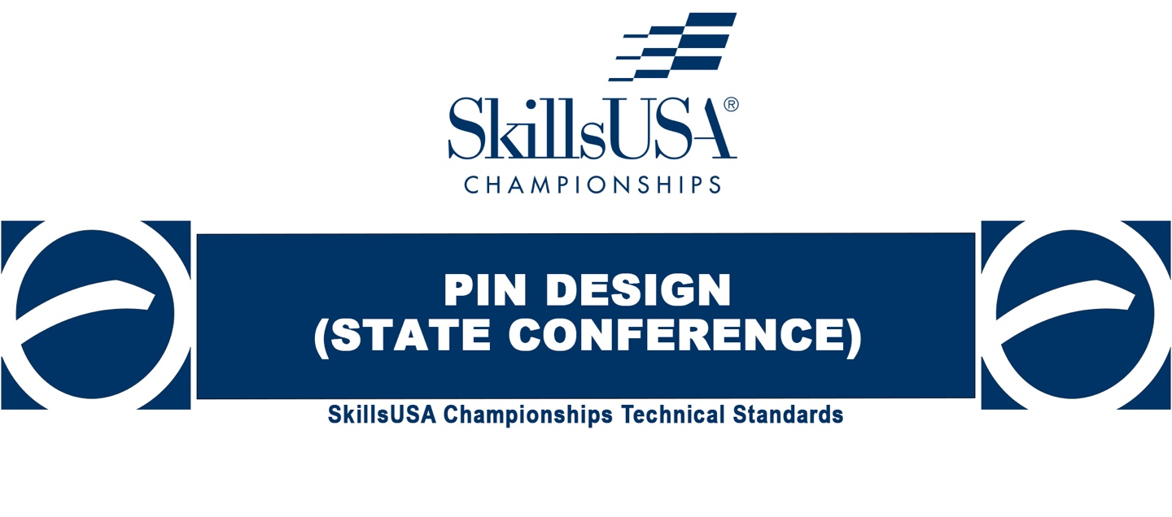
NORTH CAROLINA
CONTEST RULES
2022-23

Purpose
To evaluate a competitor’s creative, technical and oral presentation skills and to recognize outstanding students for excellence and professionalism.

First, download and review the General Regulations at: http://updates.skillsusa.org.

Eligibility
Open to active SkillsUSA members enrolled in career and technical programs. Each state may send one middle school, one high-school and one college/postsecondary competitor.

Clothing Requirements
Class A: SkillsUSA Official Attire
- Official SkillsUSA red blazer or official SkillsUSA red jacket
- Button-up, collared, white dress shirt (accompanied by a plain, solid black tie or SkillsUSA black tie), white shirt (collarless or small-collared) or white turtleneck, with any collar not to extend into the lapel area of the blazer, sweater, windbreaker or jacket
- Black dress slacks or black dress skirt (knee-length at minimum)
- Black dress shoes
Note: Wearing socks or hose is no longer required. If worn, socks must be black dress socks and hose must be either black or skin-tone and seamless/nonpattern.

**North Carolina Contest Adjustments from the National Contest:
Items highlighted in GREEN and identified as NLSC indicate National Competition Requirements that we will not require for our NC competition, but you need to be aware of these if you advance to the national competition.
Items printed in RED refer to items required for our NC Contest which are not required for the national competition.

Equipment and Materials
- Supplied by the technical committee:
  - Timekeeper and judges
  - All necessary information for the judges and technical committee

- Supplied by the competitor:
  - 8.5" x 11" rendering of pin design (must follow points in Competition Guidelines including attribution for fair use and proof of creative commons content, or permission to use copyrighted content).
  - Tabletop display to promote your pin design to the public
  - A design notebook with supporting materials for the presentation portions of the competition.
  - Means of presentation: computer, tablet, notebook, poster or other media of your choice if desired to make your presentation to the judges.
  - All competitors (except for middle school students) must create a one-page resume. See “Resume Requirement” below for guidelines.

Resume Requirement
Competitors (except for middle school students, who are exempt from this requirement) must create a one-page resume which will be the final page of the notebook for NC (see below) to submit online. SkillsUSA national competitors should submit their resume by June 1. Failure to submit a resume will result in a 10-point penalty.
Your resume must be saved as a PDF file type. If you need assistance with saving your file as a PDF, visit the Adobe website for more information.

Prohibited Devices
Cell phones or other electronic devices not approved by a competition’s technical committee are NOT allowed in the competition area.

Scope of the Competition
The competition consists of these parts:
- Evaluation of the state conference pin design
- Oral presentation and question-and-answer session. All competitors will be asked the same questions, which judges will determine before the start of the competition.
- Evaluation of the tabletop display.

Knowledge Performance
There will be no skill-related written test. Competitors are required to take the SkillsUSA professional development test. Middle-school competitors are exempt from testing requirements.

Skill Performance
The competition is designed to assess the competitor's ability to design and produce a trading pin concept for their State SkillsUSA association. In addition, competitors must create an informative, educational, and promotional tabletop display, and deliver a presentation regarding all aspects of their state pin design.

Competition Guidelines
- All entries must be rendered in color (full color or two-color). Preferably, entries will be created in a design software package such as Illustrator, or Photoshop. However, competitors are permitted to use equivalent open-source software such as Inkscape, Gimp, etc. Licensed software such as the Corel suite, Affinity Designer, Affinity Photo, etc. is also acceptable. Entries may also be hand-drawn, painted or rendered in colored pencils or markers.
- All entries should be submitted on a single 8.5"x11" page with two sizes: 7" and 1¹/₂". Both sizes must be identical. A copy for judging must be turned in at the orientation meeting with your résumé. The larger 7" version is for showing greater detail. The smaller 1¹/₂" version is to show what the actual pin will look like at pin size. The larger version must be 7" wide or 7" tall on its largest dimension for judging.
The smaller version should be 1¹/₂" wide or 1¹/₂" tall on its largest dimension to show how the actual pin will look at pin size. Deductions will be taken for each size version as follows: Every ¹/₄" over or under on the 7" version and every ¹/₈" over or under on the 1¹/₂" version. Wording on the pin must reference the name of the State, the year, and SkillsUSA. Note that both sizes should be readable, but especially at the 1¹/₂" actual pin size. Your competitor number for the national conference must be placed on the back of your submitted artwork. The SkillsUSA emblem or SkillsUSA logo (or elements of either) should not appear on the pin. The name SkillsUSA must be used and the proper spelling must be as shown (SkillsUSA is one word; accurate use of capitalization is required to represent the brand’s standards.) Learn more about SkillsUSA’s editorial and graphic style guidelines at https://brandguide.brandfolder.com/skillsusa-brand-guide/

- The design must be the original concept of the student. Use of the students’ own original photos, drawings or digital art is highly recommended. Designs may be constructed of small amounts of Creative Commons licensed material, material in the public domain, or commercial stock images. These materials must be accompanied by proof of license and must provide attribution to credit the originator.
- Designs that violate copyright laws are subject to elimination.
- A design notebook, to include:
  - Title Page. Include name of chapter, school name, school address and school telephone number.
  - Table of Contents.
  - Copy of the design.
  - Supporting documentation and information.
  - Contestant RESUME’ should be the LAST page of the notebook.
  - The “Talking Points” identified below in #6 must be included and clearly identified in the notebook.

- Competitors will deliver a five- to seven-minute 2-minute presentation regarding their design. Competitors are encouraged to memorize their presentation and use their display or visual aid only for quick reference. Competitors should always aim for good eye contact and good rapport with the judges. Strong presentations have a commanding introduction, a series of strong supporting points, and a conclusion which summarizes the topic.
Talking points should include:
  - How the competitor came up with the concept
  - The process in which the competitor designed the pin
  - Why the competitor feels it represents their state
  - What its unique qualities are
  - Why the pin would be desirable to wear, collect, or trade at NLSC
  - NOTE: All of these “Talking points” must be included and clearly identified in the notebook.
- Presenter substitutions are not permitted. However, a language translator may be allowed for students with this need. Requests for such must be made at the orientation meeting.
- After your presentation, the judges will ask questions related to Pin Design, SkillsUSA, production process, professional development, workplace, technical, and leadership skills.
- A space will be provided for you to make a tabletop display to promote your pin design/state to the public, for viewing at the national conference. You will have no more than 28" x 28" table space for this display. It should be no taller than 48" from the tabletop. Your entry submitted for judging will also be in this space. This display can be used in your presentation. Penalty Points will be assessed if your display design is outside of these dimensions.
This display must be put up within two hours after the orientation meeting and remain up until the debriefing. You will not have electricity or security for your display, so be careful not to leave valuable items on your display. The display will be judged separate from your interview. Displays should be informative and educational. Displays must also be crafted independently by the competitor. Advisors are not permitted to set up displays. (Exceptions or modifications allowed to comply with ADA for competitors with applicable disabilities). However, decorative items and craft making supplies such as stickers, lettering and such are permitted in the display.
- Displays may not include hazardous or flammable materials or generate noise.
- Displays will be judged on:
  - Neatness
  - Overall aesthetic appeal
  - Informative/educational value
  - Cohesiveness
  - Grammar/spelling
  - Size
  - Originality and creativity
  - Overall effort

- Contestants are to submit an Original Source File, NOT Compressed or Flattened.
A Packaged Native File (in addition to the original source file) is requested but not required:
- Fonts
- Colors
- links to images

************************************
North Carolina Process

- NOTEBOOK ELECTRONIC SUBMISSION:
All contestants are required to submit an electronic copy of their notebook.
The Resume’ should be the LAST page of their notebook.

- ORIGINAL SOURCE FILE SUBMISSION:
Psd, ai, indd, etc., NOT Compressed or Flattened.
A Packaged Native File is requested, but not required.

* Notebook (including Resume’) and Original Source File must be submitted through this Google Drive portal
https://drive.google.com/drive/folders/1lNuemiQooAR92D4T-Lkyui9c6vbPpDkf?usp=sharing
Deadline for electronic submission of these items is TUESDAY APRIL 4.

- ORAL PRESENTATION (on site):
In 2 minutes or less, contestant will discuss –
- The unique qualities of the pin design
- Why the Pin would be desirable to wear, collect or trade the pin at NLSC
Possible: Judges’ Questions to follow.

************************************

Standards and Competencies
PD 1.0 — Understand general design industry terminology and concepts
- Define, explain and describe various concepts related to typography, elements of design, digital images, artwork and the printing process

PD 2.0 — Demonstrate mechanical skills by creating a design on the computer within a specified amount of time
- Recall understanding and skills necessary to prepare art electronically
  - Implement correct size and orientation of design
- Recall knowledge and appropriate use of industry standard hardware and software
  - Implement correct size and placement of elements
  - Implement correct use of typography
  - Implement assignment of proper color to elements

PD 3.0 — Administer creative skills by solving a graphic design problem relevant to the skill set required for the design industry
- Apply understanding and skills necessary to create a variety of thumbnails and ideas for a given design problem
  - Implement correct number, size, scaling and color requirements of thumbnails as defined by the technical committee
  - Implement media (markers, color pencils, etc.) in the creation of thumbnails
  - Demonstrate professional presentation and technical execution of thumbnails
- Apply understanding and skills necessary to create roughs developed from thumbnails for the given design problem
  - Implement correct number, size, scaling and color requirements of thumbnails as defined by the technical committee
  - Exhibit the development of ideas from the thumbnail stage
  - Implement media (markers, color pencils, etc.) in the creation of roughs
  - Demonstrate professional presentation and technical execution of roughs
- Administer industry standard hardware and software in the creation of the project
  - Implement correct size and format for the design of the comprehensive portion of the competition
  - Exhibit the development of ideas from the rough stage
  - Implement clip art, original art and designs in the creation of the comprehensive
  - Demonstrate professional presentation and technical execution of the comprehensive

PD 4.0 — Complete an oral professional assessment in a simulated customer situation
- Perform customer-service-related activities when relating to a customer
  - Explain the function of the customer service representative
- Communicate professionally with technical knowledge
  - Describe the workings of a production environment
  - Explain the nature of work performed and requirements of customers
- Respond quickly, accurately and professionally in a customer situation

PD 5.0 — Demonstrate an understanding of the SkillsUSA Framework in the presentation.
- Apply job specific skills to the project
  - Explaining the research done for the state the pin is representing.
  - Explain the design rationale; why this design was chosen based on research done.
- Presenting personal skills
  - Explain the integrity of the design
  - Share some of the hardships that came with executing the pin, and how those were overcome.
- Apply workplace skills.
  - Explain the process of communicating, organizing, and managing the process in which this pin was created.
  - Provide examples of the commitment to leadership to complete this project.

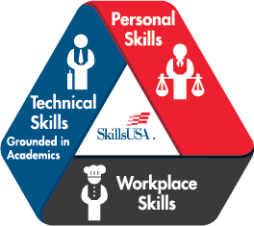
PD 6.0 — SkillsUSA Framework
The SkillsUSA Framework is used to pinpoint the Essential Elements found in Personal Skills, Workplace Skills, and Technical Skills Grounded in Academics. Students will be expected to display or explain how they used some of these Essential Elements. Please reference the graphic above, as you may be scored on specific elements applied to your project. For more, visit: www.skillsusa.org/about/skillsusa-framework/.

