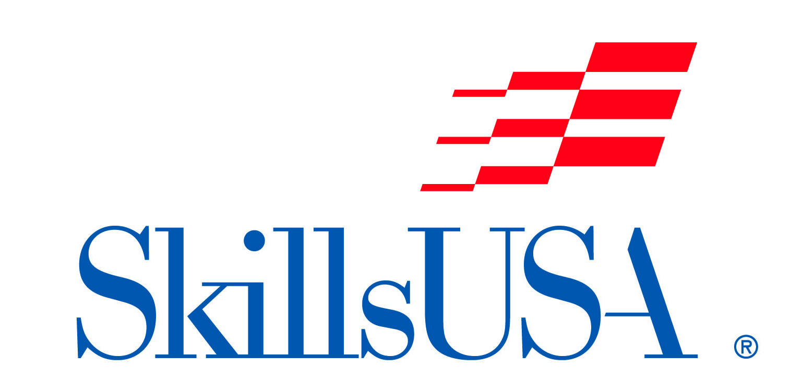
“FANTASY NAIL ART DESIGN”
Student Manikin Hand Competition
(Completed-In-Advance Showcase Design)

Date/Time: Saturday, October 22, 2022
Check-in 8:00-9:00am.
Location: NC State Fair Grounds, Raleigh, NC.
Entry Fee: $20 per contestant

THEME: DISNEY

The “Fantasy Nail Art Design” Student Manikin Hand Competition is open to all NC Cosmetology students. SkillsUSA membership is not required to compete.

Registration Instructions:
Please complete the form online at: skillsusanc.org/state-fair-events

Contest Information:
This is a manikin hand showcase competition, where all nail art design has been completed PRIOR TO competition day, and the completed manikin hand is brought to the competition site for showcasing and judging.

2 pages need to accompany the completed manikin –
- Written Description of your nail design theme (see above Theme) and the complete process (techniques) use to achieve it.
- Photos – 1 page of photos showing process of progress (example – manikin hand before the Fantasy Nail Design, 1 or more photos of the Fantasy Nail Design process.

A table will be provided for you to display your manikin hand as well as your description and photo. Since the only items you will need to provide is a completed manikin hand and 2 pages (identified above) your space allowance will be 2.5’ wide by 1.5’ deep.
Manikin Hand: student’s Choice

Manikin Hands will be judged in the following categories:
- Creativity
- Originality
- Execution
- Adaptability
- Design keeping with the given Theme (yes/no)
- Total Look

SHOW YOUR CREATIVITY!!!

Schedule:
8:30 AM – 9:30 AM Competitor/ Manikin Hand check-in & Set-up
10:00 AM – 12:00 PM Judging
1:30 PM – 1:45 PM Presentation Parade (if contestant is present)
1:45 PM – 2:00 PM Announcement of Winners

Cash Prizes will be awarded to the top (3) contestants.

(Please allow all manikin hands to remain on exhibit until Competition ends at 2:00pm).

All decisions of the judges are final.

For additional information please contact:
Morris “Boz” Boswell - Competition Chairperson
mbos324556@aol.com or (336) 214-3730
or the SkillsUSA-NC Office – 919-675-1241 or info@SkillsUSAnc.org

