SkillsUSA 2021 – Additive Manufacturing State Challenge – Power Up!

Overview

The goal of the 2021 SkillsUSA Additive Manufacturing State Competition is to challenge competitors at that state level and send the best prepared students to compete at the National Competition in June. Each year’s suggested state competition focuses on an additive manufacturing design with strict requirements on form, fit, and function of compact and intricate designs like nationals.

The below contest has been designed with the upcoming National Competition in mind and is designed to challenge the understanding of students and their skills in Additive Manufacturing.
This year’s contest challenges students to redesign an outdoor 3D-printed outlet enclose to be a USB outlet cover that leans into the needs of today’s power user.
Competitors will need to use their 3D printing knowledge to design a part that would print within the specified build volume, materials and times specified. The designed enclosure will need to match up with a testing rig overlay and meets the specified requirements on the score sheet.
Contest state chairs need to fill in blanks or modify contest to meet their contests needs or specs.
The contest descriptions have been written so that you can distribute directly to competitors. If you’d like to make modifications to fit your state’s needs, please do.

If you have questions about the contest, please email: edu.curriculum@stratasys.com

Materials & Supplies Provided by the Contestant Teams

Engineering notebook with challenge design from conception
- Students will also need to model the test rig to prove design matches
- Video Presentation with both team members

About the Testing Rig

- The Challenge Rig must be modeled by student to prove their design
- The files to print can be found on GrabCAD here:
https://grabcad.com/library/skillsusa-2020-state-challenge-1

Submit the Following Items into your Canvas Contest Access Portal:

- Notebook
- Video presentation
- Design (modeled with whatever software team is using). Submit your design in two formats:
- an STL file (This is a file that is loaded software to print the parts on a 3D printer).
- save the part files/design in a STEP file (This is a format so it can be opened in most any software versions).

All items should be submitted by April 15, 2021.

Judging Criteria:
Students will be judged on the following:
- Engineering notebooks
  - Did the students follow the guidelines provided? States are encouraged to provide their own Engineering Notebook Guidelines.
  - Did students show their design process?

- Following all requirements outlined in contest criteria
  - Dimensions
  - Build time
  - Build volume
  - Material usage
  - Support material usage
  - Did the students consider additive manufacturing when creating their design? Are they able to explain the role that additive manufacturing played in their design?

- Video Presentation
  - Does the presentation include:
    - Explanation of the design process through examples in their engineering notebook
    - Understanding of form, fit, and function

- Quality of final 3D printed part
  - Does it perform the function in the manner it was designed to do?
  - Does it meet all requirements in contest guidelines?
  - Does their design include a moving assembly?
  - Did the students design the part with additive manufacturing in mind?

- Qualifier Test (Additive Mfg Test, taken March 1-5)
SkillsUSA 2021 Additive Manufacturing
State Challenge

Power Up! - USB Outlet Redesign

Welcome to the “Power Up!” challenge! The task at hand is to design a hinged, covered enclosure (like the one pictured above) for a wall-mounted standard USB port.
“What’s the catch?” you say. Well, there are five, and here they are:

- The enclosure must match up with a USB port and mounting screw holes of the illustrated CAD below.

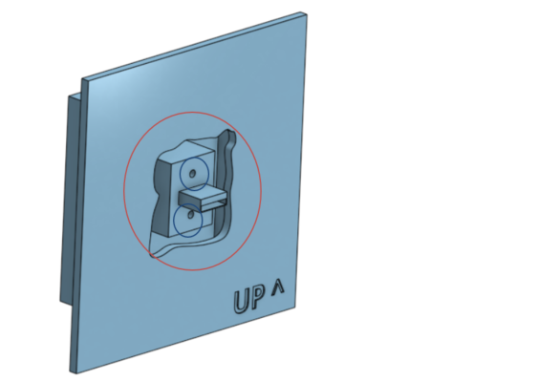
- The enclosure must completely close the “hole in the wall” of the illustrated CAD below in the red circle.

- The enclosure must have a mechanically hinged lid designed in place that does not use external parts or hardware. This enclosure lid must open at least 180 degrees and stay open at 90 degrees when placed in that position.

- Device should have some uniqueness in design – such as shape, 3D printed texture, text… the options are endless – you are the product designer – flex your creative muscle.

- The device must follow these 3D printing specs measured in GrabCAD Print (when measured using 0.010” solid ASA standard build settings):
- Prints in less than *3 hours*
- With a build volume of no greater than *3X3X3in*.
- Using no more than 5 in³ of build material
- Using no more than 2 in³ amount* of support material

Contest Criteria
- The Challenge Rig must also be modeled by student to prove their design
- The files to print can be found on GrabCAD here:
https://grabcad.com/library/skillsusa-2020-state-challenge-1
Video must include both team members and must submit:
- Engineering Notebook (Engineering notebook guidelines below)
- 3D challenge design from conception with test rig modeled for design match
- Presentation of entire project from conception to print ready

1. Engineering Notebook should:
- Be clearly labeled with contestant name(s), date and page # on each page
- Begin with a problem statement
- Include discovery and documentation of approach to solve problem
- Include sketched design concepts with critical features labeled
- Critical dimensions clearly labeled in design sketch
- Considerations for designing for FDM distinctly addressed (i.e. part strength, part orientation) especially including any expected risks during printing
- Design decisions and alternatives are documented and evaluated thoughtfully

2. 3D Printed Design - Students must create a design that:
- Prints in less than *3 hours*
- With a build volume of no greater than *3X3X3in*.
- Using no more than 5 in³ of build material
- Using no more than 2 in³ amount* of support material

- Video Presentation Criteria
- The competitor clearly describes their understanding of the problem to be solved.
- Design Process: good design logic is used for key design choices was intentional and well-communicated
- The video presentation is professional and well-rehearsed
- Practical evaluation: Part functions way team intended 100% of time.

