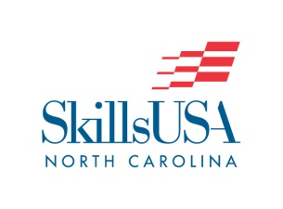
CONSTRUCTION CORE
No National Contest

PURPOSE
To evaluate each contestant’s preparation for employment and to recognize outstanding students for excellence and professionalism in the field of residential and commercial carpentry, electrical, and masonry construction trades.

CLOTHING REQUIREMENT
Official SkillsUSA khaki work shirt and pants, black or brown leather work shoes, and safety glasses with side shields or goggles. (Prescription glasses can be used only if they are equipped with side shields. If not, they must be covered with goggles.) These regulations refer to clothing items that are pictured and described at www.skillsusastore.org. If you have questions about clothing or other logo items, call 919-807-3902.
Contestants must wear their official contest clothing to the contest orientation.

SAFETY REQUIREMENT
Both the instructor and the contestant certify by agreeing to enter this contest that the contestant has received instruction and has satisfactorily passed an examination on the safe use of a portable power saw. They also certify that the contestant’s saw has been thoroughly inspected and is in safe working condition. Further, they agree that SkillsUSA, SkillsUSA North Carolina, and the SkillsUSA Championships Technical Committee and judges are released from all responsibility relating to personal injuries resulting from its use. Contestants will be removed from competition if proper training has not been provided and/or they are using equipment in an unsafe manner.

ELIGIBILITY
Open to active SkillsUSA members in programs with carpentry, electrical trades, and masonry as the occupational objective ( Core and Sustainability). Students may not have taken or are currently taking any Carpentry I, Electrical Trades I, or Masonry I course at the time of competition.

EQUIPMENT AND MATERIALS
1. Supplied by the technical committee:
a. All lumber and materials, as specified on the job sheet(s).
b. Job Sheet and blueprints for each contestant and judge.
c. All necessary information and furnishings for the judge and technical committee.

2. Supplied by contestant/Rev. (3/4/2019)
a. Safety glasses
b. Calculator
c. 16 oz. nail hammer (curved or straight)
d. Speed Square
e. Set of Phillips / T20 torx head drivers
f. 16’ or larger tape measure
g. Pencils
h. Portable electric sander or sponge
i. 50’ power cord (UL approved ground)
j. Power circular handsaw with new carbide-tipped bit
k. Blade wrench for your circular saw
l. 5/8ths wood drill bit
m. nail set for 4/6 penny finish nails
n. Cordless/corded drill/impact driver
o. Pair of saw horses
p. Pair of clamps (to hold down 1x6 to saw horses)
q. 1.5” wood hole saw with pilot bit

3. Additional Items supplied by contestant:
a. Resume
b. Construction Core Contest Verification Form

SCOPE OF THE CONTEST
  - In addition to a hands-on performance component, the contest may include a written knowledge tests that assesses knowledge of Construction Core areas, including but not limited to safety, hand and power tools, building materials, construction math, and blueprint reading.

CONTEST GUIDELINES
1. The contest will assess accuracy, workmanship, the ability to read and interpret blueprints, and the proper use of tools and equipment safely.
2. Contestants will be judged on knowledge of objectives and the use of all tools and the proper use of PPE.
3. Time Limit – Contestants will be stopped when time limits as specified on the contest job sheet are up. However, contestants may stop whenever they have completed a particular phase of the contest.
4. The dismantling of any project and cleanup of our completion area will be considered the final sequence or task of this contest.

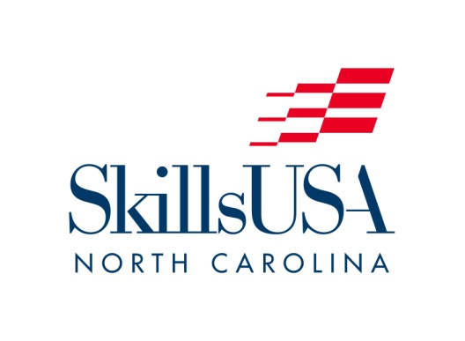

CORE CONTEST VERIFICATION FORM

Contestant: ____________________________________________

School: _______________________________________________

Contest: ______________________________________________

I do hereby acknowledge that the contestant listed above –

___ has not taken a Level I course in the content area listed above, and

___ is not currently enrolled in a Level I course in the content area listed above.

(Both boxes must be checked in order to qualify for a Core skill contest.)

Signatures:

_______________________________ ________________________________
(Student Signature) (Print Name)

_______________________________ ________________________________
(Advisor Signature) (Print Name)

_______________________________
Date

** PLEASE NOTE:

This form is required for ALL Core contests – Carpentry Core.

This completed and signed form MUST be brought with contestant to the contest orientation. Failure to provide this Verification Form to contest chairperson will result in a point deduction.

