Barbering (Men’s Haircutting) Contest Standards

PURPOSE
To evaluate each contestant’s preparation for employment and to recognize outstanding students for excellence and professionalism in the field of barbering.

ELIGIBILITY
Open to active SkillsUSA members enrolled in programs with barbering and cosmetology as the occupational objective.

CLOTHING
White Polo shirt, Black Dress Slacks (no jeggings or leggings, no spandex, no yoga pants, no skin-tight pants, no denim), Black belt with no ornamentation (if slacks have belt loops), Black dress socks or black or skin-tone hose is allowed under slacks, Black leather work shoes (closed toe).
No jewelry or watches (excluding wedding bands)
If students show up in attire that is unprofessional, they are not allowed to compete.

EQUIPMENT AND MATERIALS

Supplied by the Technical Committee:
- Tables
- Timer / time-keeper
- Electrical outlet
  - First Aid kit and Blood Spill kit
- Contestant's diagram/picture of haircuts
- Any and all pictures or literature of styles, haircuts and technical

Supplied by the contestant:
- MR.SAM SHOULDER MANIKIN WITH BEARD #SAM-9 - as delivered - no precutting
Note: To purchase manikins, call Burmax 1-800-645-5118 Service Dept - Ask for a SkillsUSA discount
- Small broom and dust pan
- Pencil/pen
- Note Pad (for Oral Communications Segment)
- 1 Large trash bag for soiled linens and such, no labelling needed
- Disinfectant spray
- Resume
- Optional Suggested Items: Mirrors
- BARBERING KIT –
  - Cutting shears
  - Thinning shears
  - Razor and spare blade
  - Clippers
  - Trimmers
  - Blow dryer
  - Styling products of choice
  - Finishing spray
  - Combs of choice
  - Brushes
  - Spray bottle (filled with water)
  - Towels
- All-purpose cape
  - Sectioning Clips
- Sanex Neck strips
- All-Purpose Cape

GENERAL CONTEST INFORMATION
- Contestant Folder – Contestants are to prepare a folder to present to the Chairperson at orientation. Contents of the folder should include:
- Resume – All contestants will turn in a typed, 1 page, professional resume.

- Talking – No talking to other contestants, instructors, or audience members during the competition is allowed. Doing so may result in disqualification. If you have a question, raise your hand and a sage or the competition chairperson will see to your needs.

- Breaks – Breaks will be given during competition. Contestants are not allowed to leave the area except with a chaperone for restroom visits or emergencies. If contestant gets sick during the competition and need to leave the contest area, no extra time will be allotted.

- Work Time – You can begin the contest when the chairperson signals so and you must stop when time is called. Continuing to work will result in point deductions. All contestants must participate in all phases of the competition, including written (if applicable) and Oral Communications.

- Upon completion of the competition – DO NOT Remove Manikins from the competition area until instructed to do by the contest chairperson.

- Sanitation – Contestant must disinfect and clean-up their work station/area, which includes a total breakdown of their work station/area. 1 Trash Bag is required, no labeling needed. THIS IS NOT STATE BOARD SANITATION – Just what we are requiring for this competition. Sanitation for this contest includes –
- Sanitizing the workspace at the beginning,
- Sanitizing the workspace at the end,
- Items are not thrown on the floor throughout the competition, and
- All used items go in the trash bag.

- Secondary contestants will compete against secondary and postsecondary will only compete against postsecondary.

- JUDGES DECISIONS ARE FINAL

SCOPE OF THE CONTEST / STANDARDS AND COMPETENCIES

BA 1.0 — Pompadour Hair Cut Design: Duplicate a haircut and style that has been preselected by the technical committee within a 60-minute time period
1.1 Duplicate the haircut using shears, thinning shears, texturizing shears, razor, trimmers, and/or clippers.
1.2 Demonstrate fading, blending, sectioning, lining and finishing.
1.3 Duplicate the length, design line and textured look of the selected cut
1.4 Duplicate the finished design using blow dryer or thermal tools such as curling iron, flat iron, etc., as needed.
1.5 Use appropriate styling products to duplicate the selected haircut
1.6 Duplicate the balance of form, control of texture and the control of the hair direction

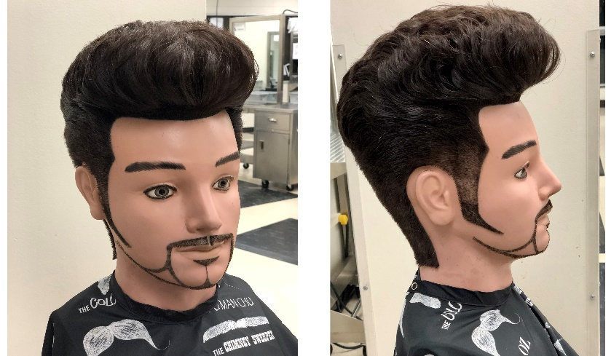

BA 2.0 — Men’s Creative Pompadour Design Cut and Beard Design: Create a pompadour (using previous cut pompadour) and beard design of your choice within a 60-minute time period

2.1 Create a design of your choice on the pompadour and beard design.
2.2 Identify the theme connecting the beard and pompadour design on the sketch sheet
2.3 Demonstrate balance, proportion and form in the finished pompadour and beard design
2.4 Show control of texture and control of hair direction in the finished design
2.5 Incorporate current trends in both pompadour and beard design
2.6 Clean area

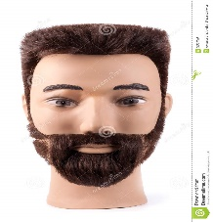

BA 3.0 — Men’s Flat Top Cut: Duplicate a predetermined haircut and design that has been selected by the national technical committee within a 60-minute time period
3.1 Duplicate the haircut using shears, thinning shears, texturizing shears, razor and/or clipper, as needed
3.2 Duplicate the length and design line of the selected cut
3.3 Demonstrate fading, blending, sectioning, lining and finishing
3.4 Use appropriate styling products to duplicate the selected haircut

SCORING INFORMATION
- Haircut #1 (Pompadour) – 300 points
- Haircut #2 (Beard Design) – 300 points
- Haircut #3 (Flat Top) – 300 points
- Oral Communication – 100 points
- Point Penalty Categories:
- Incorrect Manikin – 200 point deduction
- Late Arrival penalty – 200 point deduction
- Sanitation / Clean-up – up to 100 point deduction.
- Kit Check – up to 30 point deduction
- Clothing penalty – up to 10 point deduction
- Resume penalty – 10 point deduction

ORAL COMMUNICATIONS SCENARIO:
“BOOKING AN APPOINTMENT BY PHONE”

** All Cosmetology-related competitors will perform an oral interview.

- Mock telephone conversation scenario: Booking an appointment with a first-time client. The client is new to the area. The client will be booking the appointment in the cosmetology/contest discipline area that the students is competing in.
- Competitors may bring note pad and pencil to write down information.
- Judge will be seated across from the competitor acting as the client.
- Judging Criteria:
- 10 pts - Pleasant voice
- 10 pts - Identified salon
- 10 pts - Identified stylist
- 10 pts - Asked for client’s first and last name
- 10 pts - Asked for client’s phone number
- 10 pts - Asked for type of service client is requesting
- 10 pts - Used client’s name at least once in the conversation
- 10 pts - Confirmed service to be done, time and date
- 10 pts - Suggested additional services
- 10 pts - Outstanding presentation
- 100 points total

