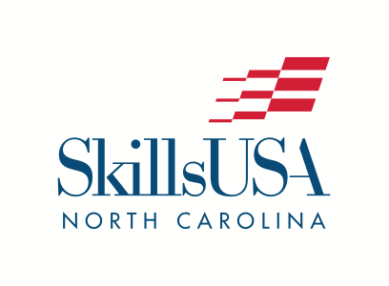
P.O. Box 28064
Raleigh, NC 27611
Phone: (919) 675-1241
info@SkillsUSAnc.org
www.SkillsUSAnc.org

2021 PRESS RELEASE
FOR IMMEDIATE RELEASE

June 24, 2021 - NAME, AGE, of CITY, NC, has WON or RANKED and/or received a Skill Point Proficiency Certificate or participated in the SkillsUSA national championship competition in NAME OF CONTEST. The SkillsUSA Championships, held virtually this year, took place June 1-18, 2021, as part of the 57th SkillsUSA National Leadership and Skills Conference (NLSC), a showcase of career and technical education students. During the conference, approximately 3700 outstanding career and technical education student state contest winners competed in over 100 different hands-on trade, technical and leadership fields. 101 North Carolinians from 19 high schools and 8 community colleges participated in the SkillsUSA National Leadership and Skills Conference virtually.

FIRST NAME is a GRADE at SCHOOL NAME. [Add a quote here. Example: “We are very proud of John’s accomplishments,” said Sam Smith, John’s advisor at Monroe.] He/She and the other students that participated in the NAME CONTEST competition are true champions in their dedication to excellence in their trade and their leadership skills.

During the national competition, STUDENT NAME and other students worked against the clock and each other, proving their expertise in occupations like electronics, computer-aided drafting, precision machining, automotive, welding, medical assisting, cosmetology and culinary arts. All contests are run with the help of industry, trade associations, and labor organizations, and test competencies are set by industry. In addition, leadership contestants demonstrated their skills in several Leadership Development competitions, which included both prepared and extemporaneous speaking, engaging in both individual and team presentations.

Top student winners received gold, silver and bronze medallions. Many also received prizes such as tools of their trade and/or scholarships to further their careers and education. The SkillsUSA Championships is for high school, middle school and college-level students who are members of SkillsUSA.

North Carolina was very well represented in the SkillsUSA Championships, earning a total of 33 medallions (tied for sixth highest total medal count in the nation). Students earned 19 gold, 1 silver, and 13 bronze medals.

SkillsUSA is a nonprofit partnership of education and industry founded in 1965 as Vocational Industrial Clubs of America (V.I.C.A.) to strengthen our nation’s skilled workforce. Driven by employer demand, SkillsUSA helps students develop necessary personal and workplace skills along with technical skills grounded in academics. This SkillsUSA Framework empowers every student to succeed at work and in life, while helping to close the skills gap in which millions of positions go unfilled. Through SkillsUSA’s championships program and curricula, employers have ensured schools are teaching relevant technical skills, and with SkillsUSA’s new credentialing process, they can now assess how ready potential employees are for the job. SkillsUSA has hundreds of thousands of members nationwide in high schools, middle schools and colleges, covering over 130 trade, technical and skilled service occupations, and is recognized by the U.S. Departments of Education and Labor as integral to career and technical education. With the addition of our alumni, membership last year was over 400,000. SkillsUSA receives in-kind and financial support from more than 650 national partners. SkillsUSA has served more than 13.8 million members since 1965. For more information, go to SkillsUSA.org and SkillsUSAnc.org .

###

